Santhosh Ramesh(UST,IN)

UST GLOBAL, 289597@ust.com

CAPSTONE PROJECT REPORT

**Project Documentation: Budget Ledger: Goldencat Bank Application**

This document provides a comprehensive overview of the CI/CD pipeline, Dockerization, and Kubernetes deployment strategy for the **Budget Ledger - Goldencat Bank Application**. The application, built with a serverless backend and a modern frontend, is designed to provide secure and efficient financial tracking. This document details the architecture, build processes, security scanning, deployment considerations, advanced AWS service integrations, and key project outcomes, all tailored to the application's unique requirements.

**Main areas covered:**

1. **Application Deployment in AWS EKS:** Details the deployment of the containerized application within an Amazon EKS cluster. The document explains how Docker images are stored in Amazon ECR (Elastic Container Registry) and accessed by the EKS cluster, with the application being exposed to end-users via an AWS Load Balancer.
2. **Automation with AWS CodePipeline:** Explains the end-to-end automation of the application's build, test, and deployment process using AWS CodePipeline. This includes source code integration, build stages with CodeBuild, and deployment to the EKS cluster.
3. **Multi-Region Deployment for High Availability:** Describes the advanced multi-region deployment strategy for disaster recovery and high availability.
   * Primary Region (North Virginia - us-east-1): Details the use of AWS CloudFormation to provision and manage the EKS cluster and related resources.
   * Secondary Region (Ohio - us-east-2): Explains the use of Terraform for creating and managing resources in the second region, demonstrating an infrastructure-as-code approach with different tools.
   * Deployment: Details how AWS CodeBuild and AWS CodeDeploy are used to deploy the application to the EKS clusters in both regions.
4. **Disaster Recovery and Failover:** Outlines the robust disaster recovery plan using Failover Routing in AWS Route 53.
   * Primary Region Failover: Describes the setup for automatic failover from the primary region (us-east-1) to the secondary region (us-east-2).
   * AWS Backup: Explains how AWS Backup is used to create and manage backups of critical resources.
   * Automated Failover Logic: Details the implementation of AWS EventBridge, Lambda functions, and SNS topics to trigger the CodePipeline and primary region failover based on monitoring events, ensuring continuous application availability.
5. **Comprehensive Monitoring:** Describes the dual-pronged monitoring strategy to ensure the application's health and performance.
   * CloudWatch: Utilizes Amazon CloudWatch in the primary us-east-1 (North Virginia) region for centralized logging, metrics, and alerting.
   * Prometheus and Grafana: Implements an open-source monitoring stack with Prometheus for metric collection and Grafana for visualization and dashboards in the secondary us-east-2 (Ohio) region.
6. **Security Scanning:** Describes the integration of security tools within the CI/CD pipeline to scan for vulnerabilities in the code and Docker images.
7. **Advanced AWS Service Integrations:** Explores how services like AWS Lambda, Amazon API Gateway, and Amazon DynamoDB are integrated to create a scalable, serverless backend.
8. **Key Project Outcomes:** Summarizes the successful implementation of a robust, scalable, and secure application that empowers users to manage their financial budgets effectively.

**PROJECT OVERVIEW**

The **"Budget Ledger - Goldencat Bank Application"** is a robust, web-based financial management service designed to provide core banking functionalities with a strong focus on personal budgeting and transaction tracking. As evidenced by the user interfaces—including the secure login, registration, dashboard, and transaction history pages—the application provides a clean and intuitive user experience.

The project is built on the **Spring Boot framework (Java)**, as indicated by the pom.xml and mvnw files in the repository. It leverages **Maven** as its build automation tool, ensuring a standardized and repeatable build process. The presence of buildspec.yml, deployment.yaml, service.yaml, and budget.yaml highlights a strong focus on automated deployment and resource management.

The application embraces cloud-native principles by being containerized with **Docker**, as shown by the Dockerfile in the repository. This containerization ensures that the application can run consistently across different environments. It is slated for deployment on **Kubernetes clusters**, with configuration files like deployment.yaml and service.yaml ready for orchestration.

The entire lifecycle, from code commit to deployment-ready artifacts, is automated through a sophisticated **AWS CodePipeline CI/CD pipeline**, supporting both single-region and multi-region deployments. This advanced setup, as detailed in the project documentation, leverages services like AWS EKS, ECR, Load Balancers, and a combination of AWS CloudFormation and Terraform for robust, multi-region infrastructure management. The application's core functionality includes user authentication, account management, and transaction processing, with a clear transaction history ledger to help users track their financial activity.

**APPLICATION INTERFACE**

* Login Page

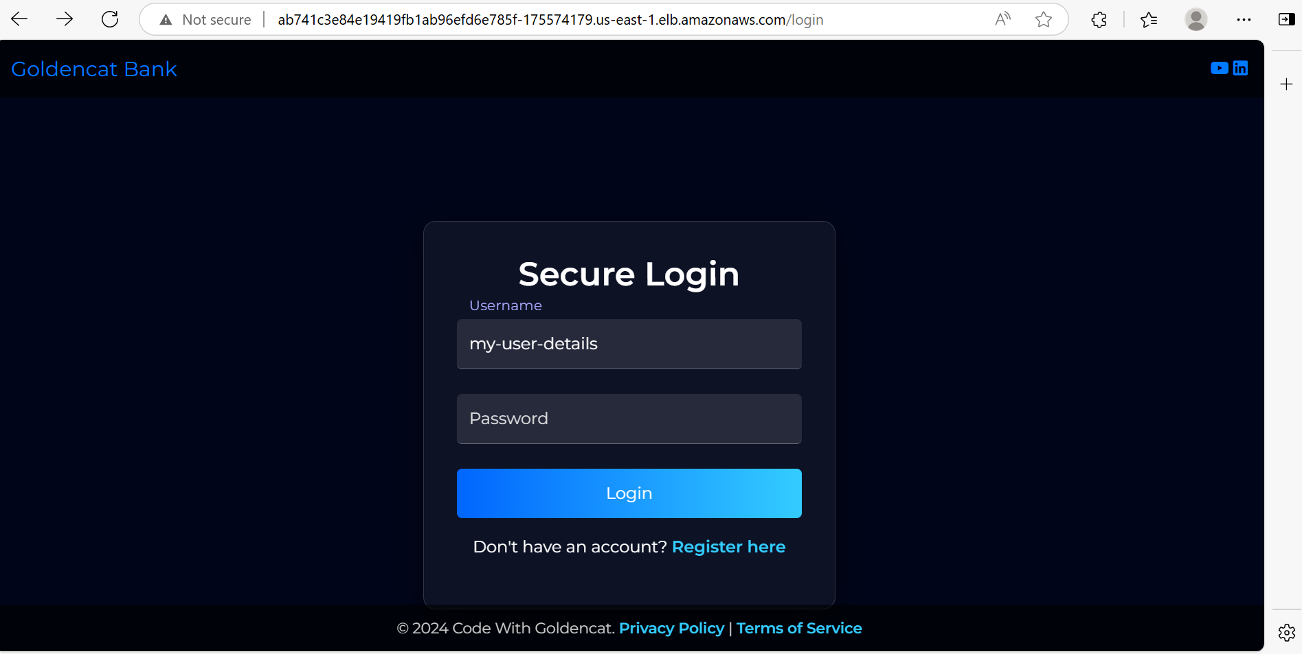

* Register Page

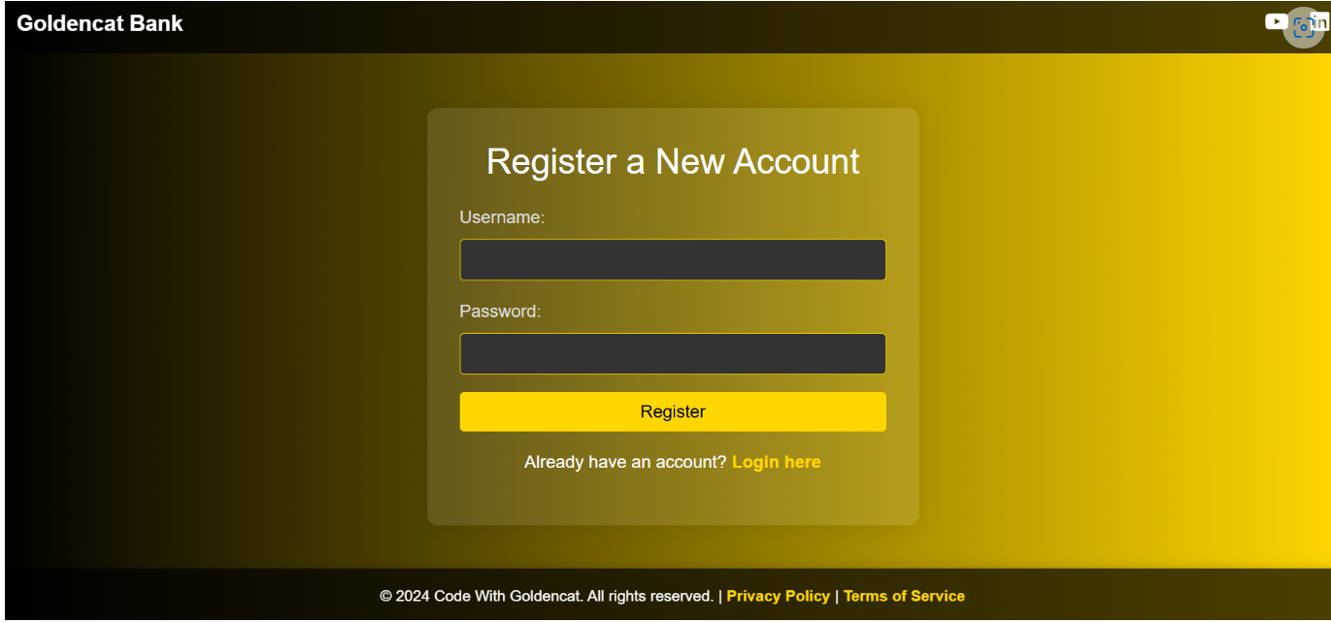

* Dashboard Page

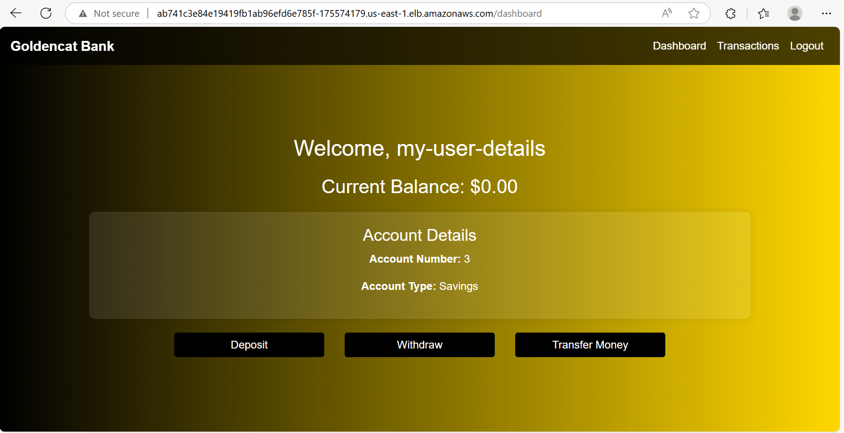

* Transactions Page

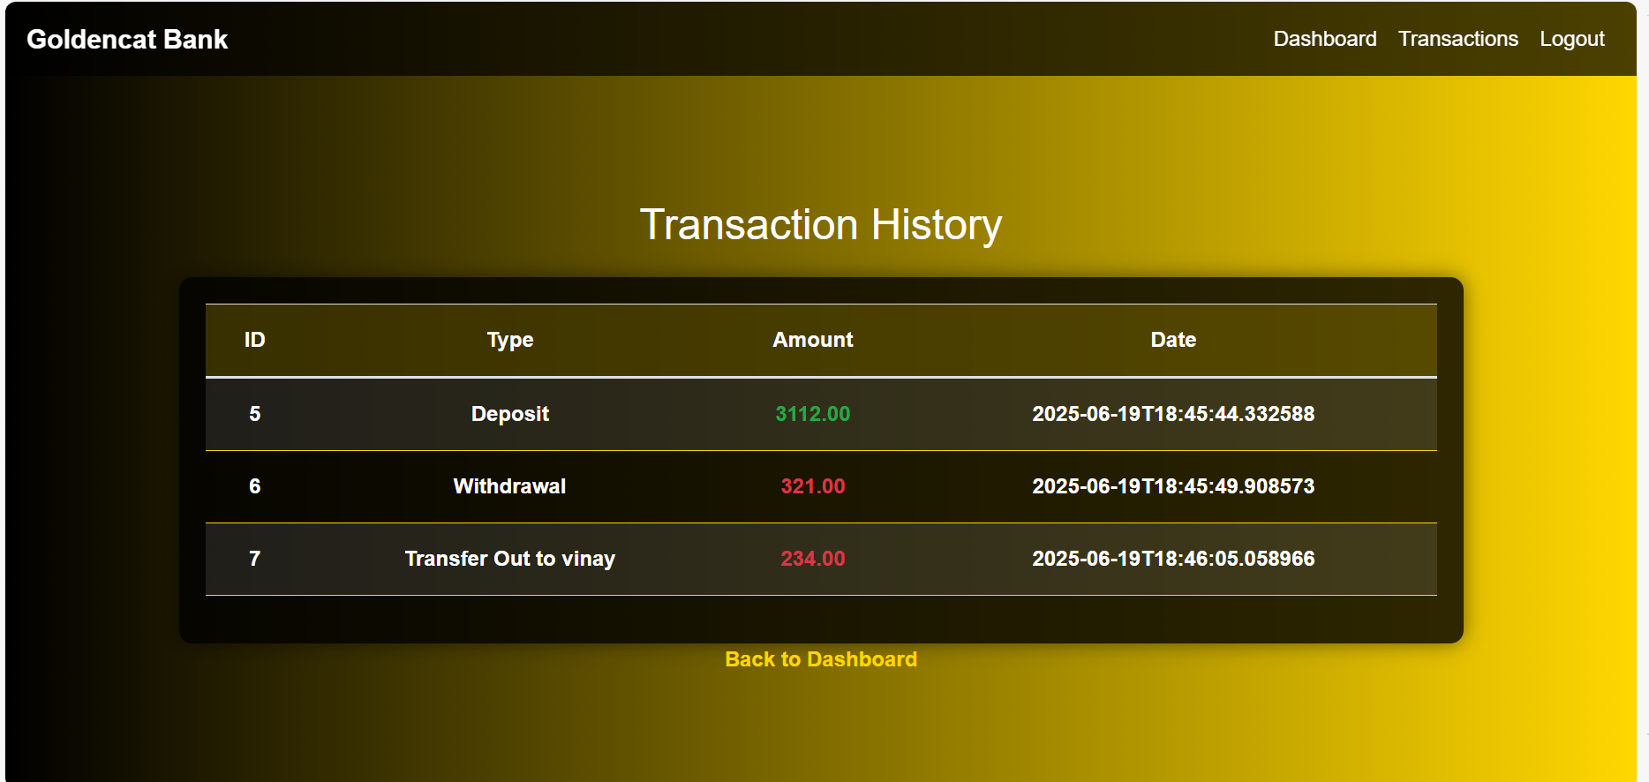

**2. PROJECT ARCHITECTURE**

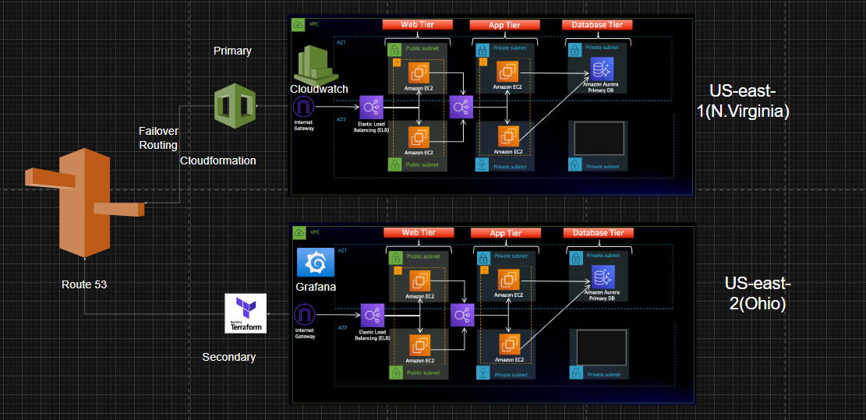

**2.1 Architecture Overview**

The solution is architected on a modern, cloud-native foundation, designed for scalability, resilience, and operational efficiency. It leverages a suite of core AWS services and powerful open-source technologies to ensure high availability and robust disaster recovery capabilities.

**Core Components and Services:**

* **Application Layer:** The system's business logic and API endpoints are driven by a Spring Boot application. This self-contained application is designed to be easily deployed and managed, forming the core of the system's functionality.
* **Data Persistence:** Data is managed by a MySQL database, provisioned as a fully-managed service through Amazon RDS (Relational Database Service). This choice simplifies database administration tasks, offering built-in high availability with Multi-AZ deployments, automated backups, and enhanced security features.
* **Containerization:** The application is encapsulated within lightweight, portable Docker containers. This approach guarantees consistent behavior and execution of the application across all environments, from development to production.
* **Container Image Repository:** The Docker images are securely stored and versioned in Amazon ECR (Elastic Container Registry). ECR serves as the central hub for all container images, seamlessly integrating with AWS's build and deployment services, including AWS CodeBuild and Amazon EKS.
* **Container Orchestration:** The containerized application is deployed and managed across multiple Amazon EKS (Elastic Kubernetes Service) clusters. Kubernetes provides sophisticated orchestration features, including load balancing, auto-scaling, and self-healing capabilities, ensuring the declarative management of containerized workloads.
* **Automated Release Pipeline:** The entire software delivery lifecycle is automated through AWS CodePipeline and AWS CodeBuild. This Continuous Integration/Continuous Delivery (CI/CD) pipeline automates the journey from source code commit to deployment. Within this pipeline, AWS CodeBuild is responsible for building the application, running security scans, pushing images to ECR, and generating deployment manifests.
* **Global Traffic Routing:** For intelligent traffic management and multi-region routing, the solution utilizes Amazon Route 53. This service provides advanced DNS capabilities, including failover routing and targeting multiple Application Load Balancers (ALBs) across different regions, crucial for ensuring high availability and a robust disaster recovery strategy.
* **Monitoring and Observability:** To maintain real-time visibility into the health and performance of the application and infrastructure, the system uses a combination of monitoring tools. Amazon CloudWatch is used for centralized log and metric collection, while Grafana provides powerful data visualization and dashboarding capabilities.
* **Event-Driven Automation:** To enable automated responses to system events, Amazon EventBridge is integrated. This service facilitates real-time alerts and triggers, allowing for automated actions based on predefined event patterns.
* **Data Protection and Backup:** To ensure the integrity and recoverability of critical data, AWS Backup is employed. This centralized service provides automated and policy-driven backup and recovery for a wide range of AWS resources, including the RDS database.

**AWS Deployment Prerequisites**

Before deploying the application using the CI/CD pipeline, ensure the following AWS infrastructure and configurations are in place:

* **Active AWS Account:**  
  A valid AWS account with necessary billing and access configured.
* **VPC and Subnets:**
* A properly designed **Virtual Private Cloud (VPC)** with public and private subnets spanning multiple **Availability Zones** for fault tolerance and network isolation.
* **Amazon RDS MySQL Database:**

A **MySQL** instance named mydb deployed in **Amazon RDS**, configured for multi-AZ for high availability. Ensure security groups allow access from the EKS cluster within the same VPC.

* **Amazon Elastic Container Registry (ECR):**  
  A private **ECR** repository called online-banking to store and manage Docker images.
* **Amazon EKS Clusters:**  
  Active **EKS** clusters running in both **us-east-1** and **us-west-1** regions. Required configurations include:
  + Proper IAM roles for EKS worker nodes to pull images from ECR.
  + Functional kubeconfig for cluster interaction.
* **IAM Roles and Required Permissions:**
  + **CodeBuild Role:**  
    Must have permissions to:
    - Access ECR for pushing and pulling images (ecr:GetAuthorizationToken, ecr:PutImage, etc.).
    - Interact with **S3** for storing source code and build artifacts.
    - Query RDS instances (rds:DescribeDBInstances).
    - Publish logs to **CloudWatch Logs**.
  + **EKS Worker Node Role:**  
    Requires permissions to pull images from **ECR**.
  + **CodePipeline Role (if applicable):**  
    Required if **AWS CodePipeline** is used to automate deployments. This role must:
    - Trigger CodeBuild jobs.
    - Deploy to EKS using **kubectl** or **eksctl**.
    - Access **S3** for artifacts management.
* **Kubernetes Deployment Files:**  
  Ensure your source repository contains valid k8s/deployment.yaml and k8s/service.yaml files with placeholders for the image tag (IMAGE_PLACEHOLDER) ready for replacement during deployment.
* **Maven Configuration:**  
  A maven-settings.xml file should exist in the root directory of the source repository, along with the Dockerfile, to enable Maven mirror functionality during builds.

**3. INFRASTRUCTURE COMPOSER**

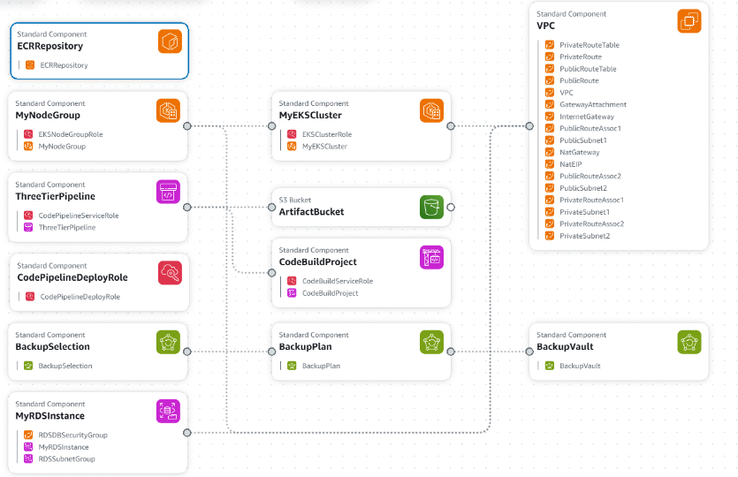

**Detailed Infrastructure Components**

The infrastructure for this project is built upon a comprehensive suite of AWS services, each provisioned to serve a specific function within the architecture. These components are designed to work together to ensure a robust, scalable, and secure system.

* ECR Repository: A dedicated repository for securely storing and managing the application's Docker images. This acts as the central hub for container images used throughout the deployment process.
* EKS Cluster and Worker Nodes:
  + MyEKSCluster: This is the core Amazon EKS (Elastic Kubernetes Service) cluster, which orchestrates and manages the containerized workloads. Its operations are governed by an EksClusterRole.
  + MyNodeGroup: This represents the collection of Amazon EC2 worker nodes that run the application containers within the EKS cluster. These nodes are managed by an EksNodeGroupRole.
* Storage for Artifacts: An S3 Bucket, designated as the ArtifactBucket, is utilized to store various build artifacts, logs, and other data generated by the CI/CD pipeline stages.
* CI/CD Pipeline Components:
  + CodeBuildProject: An AWS CodeBuild project definition that handles the build, testing, and container image creation processes. It operates under a CodeBuildServiceRole to access necessary resources.
  + CodePipeline: The automation of the software release process is handled by a multi-stage CI/CD pipeline, referred to as the ThreeTierPipeline. The pipeline's execution is managed by a dedicated CodePipelineDeployRole.
* Data Protection and Backup: A data protection strategy is implemented using AWS Backup, comprising three key components:
  + BackupPlan: Defines the backup policy, including frequency and retention periods.
  + BackupSelection: Specifies the AWS resources that are included in the backup plan.
  + BackupVault: The secure, logical container where the backups are stored.
* Database Resources: The project's database is a managed Amazon RDS MySQL instance, named MyRDSInstance. It is protected by a dedicated RDSDBSecurityGroup and placed within an RDSSubnetGroup for network isolation.
* Networking Infrastructure (VPC Components): A robust and secure networking environment is established using a Virtual Private Cloud. Key networking components include:
  + The VPC itself.
  + PublicSubnet and PrivateSubnet definitions for organizing resources based on their accessibility.
  + InternetGateway and NatGateway to enable outbound internet access for private resources.
  + PublicRouteTable and PrivateRouteTable for managing network traffic flow.
  + GatewayAttachment to connect the VPC to the Internet Gateway.

**CI/CD Pipeline with AWS CodeBuild (buildspec.yml)**

The buildspec.yml file serves as the core blueprint for the Continuous Integration and Continuous Delivery (CI/CD) workflow within AWS CodeBuild. It outlines a systematic process for building, validating, securing, and preparing the application for deployment. The project utilizes two distinct, end-to-end DevOps pipelines—one managed by **CloudFormation in us-east-1** and the other by **Terraform in us-west-1**, demonstrating a robust multi-region deployment strategy.

**3.1. Environment Variables**

The env section centralizes crucial parameters, enhancing the reusability and adaptability of the buildspec.yml script. These variables are configured to be injected into the build environment:

* **DB_USERNAME, DB_PASSWORD:** Credentials required for database connectivity. For production, these sensitive details should be retrieved securely at runtime from a secrets management service like **AWS Secrets Manager**.
* **CLUSTER_NAME:** The identifier for the target Kubernetes cluster where the application will be deployed.
* **AWS_REGION:** The specific AWS region where resources (e.g., ECR, RDS, CodeBuild) are provisioned, such as us-east-1 or us-west-1.
* **AWS_ACCOUNT_ID:** Your unique AWS account ID, which is essential for constructing the full URI for the ECR image.
* **IMAGE_NAME:** The designated name for the Docker application image (e.g., online-banking).

**3.2. Install Phase**

This phase is dedicated to installing essential tools and dependencies within the CodeBuild environment before the primary build process commences.

* yum update -y: Updates all pre-installed packages on the build agent to their latest versions, which helps mitigate security vulnerabilities and resolve compatibility issues.
* yum install -y unzip wget python3-pip gnupg tar: Installs a suite of foundational utilities necessary for tasks like downloading files (wget), decompressing archives, and managing Python packages (pip). gnupg is included for verifying software signatures.
* pip3 install --upgrade awscli: Upgrades the **AWS Command Line Interface (CLI)** to its most recent version, ensuring full compatibility with the latest AWS API functionalities.
* **kubectl Installation:**
  + curl -LO "https://dl.k8s.io/release/v1.29.0/bin/linux/amd64/kubectl": Downloads the kubectl binary, a critical tool for interacting with the Kubernetes cluster and preparing deployment manifests.
  + chmod +x kubectl && mv kubectl /usr/local/bin/: Makes the downloaded kubectl binary executable and moves it to a directory included in the system's PATH.
* **Trivy Installation:**
  + echo Installing Trivy...: A helpful log message.
  + curl -sfL https://raw.githubusercontent.com/aquasecurity/trivy/main/contrib/install.sh | sh -s -- -b /usr/local/bin: Executes the official **Trivy** installation script. This method is highly reliable as it automatically fetches the latest stable version and handles platform-specific details, preventing potential errors from outdated download links and ensuring that security scans use the most current vulnerability database.

**3.3. Pre-build Phase**

This phase handles crucial setup and configuration tasks just before the main build and security scanning operations.

* echo Logging in to Amazon ECR...: A descriptive log message.
* aws ecr get-login-password --region $AWS_REGION | docker login --username AWS --password-stdin ${AWS_ACCOUNT_ID}.dkr.ecr.${AWS_REGION}.amazonaws.com: This command performs a secure authentication of the Docker daemon with your Amazon ECR repository. It fetches a temporary token from ECR and passes it to the docker login command, authorizing the build environment to push and pull images.
* **RDS Endpoint Retrieval:**
  + export RDS_ENDPOINT=$(aws rds describe-db-instances --query "DBInstances[?DBName=='mydb'].Endpoint.Address" --output text --region $AWS_REGION): This command dynamically retrieves the network address of your Amazon RDS database instance, which is essential for the application to establish a database connection.
  + echo "RDS_ENDPOINT=$RDS_ENDPOINT": Displays the retrieved RDS endpoint in the build logs for verification.
* export IMAGE_URI="${AWS_ACCOUNT_ID}.dkr.ecr.${AWS_REGION}.amazonaws.com/${IMAGE_NAME}:latest": This command constructs the complete, fully-qualified URI for your Docker image in ECR, which will be used for tagging and deployment.

**3.4. Build Phase**

This is the central phase where the application is compiled, containerized, and scanned for vulnerabilities.

* echo Building Docker image...: A progress log message.
* docker build -t $IMAGE_NAME .: Builds the Docker image for the application using the Dockerfile located in the current directory, tagging it with a local name (online-banking).
* docker tag $IMAGE_NAME:latest $IMAGE_URI: Creates a secondary tag for the locally built image, aligning it with the full ECR repository URI.
* echo Scanning image with Trivy...: A log message for the security scanning step.
* mkdir -p trivy-reports: Creates a dedicated directory to store the Trivy scan report.
* trivy image --severity HIGH,CRITICAL --exit-code 0 --format table -o trivy-reports/report.txt $IMAGE_NAME:latest || true: Executes the Trivy vulnerability scan.
  + --severity HIGH,CRITICAL: Limits the report to vulnerabilities of "High" or "Critical" severity, focusing on the most significant threats.
  + --exit-code 0: **Crucially, this ensures the CodeBuild step does not fail** even if vulnerabilities are discovered, allowing the pipeline to continue and providing the report as a build artifact for review. For stricter pipelines, this could be changed to 1 to enforce a security gate.
  + --format table: Formats the scan results in a clear table format for the console output.
  + -o trivy-reports/report.txt: Saves the complete scan report to a file.
  + || true: A shell command safeguard that ensures the step completes successfully even if trivy were to exit with a non-zero code, preventing premature build termination.

**3.5. Post-build Phase**

This phase finalizes the build process by pushing the container image to ECR and preparing the Kubernetes deployment files.

* echo Pushing Docker image to ECR...: A log message.
* docker push $IMAGE_URI: Uploads the newly built and tagged Docker image to the Amazon ECR repository, making it available for deployment to the EKS cluster.
* echo Preparing Kubernetes manifests...: A log message.
* mkdir -p k8s-out: Creates a directory (k8s-out) to store the finalized Kubernetes deployment manifests.
* sed "s|IMAGE_PLACEHOLDER|$IMAGE_URI|g" k8s/deployment.yaml > k8s-out/deployment.yaml: This command uses sed to dynamically replace the IMAGE_PLACEHOLDER in the deployment.yaml template with the actual ECR image URI. This is a vital step for ensuring that Kubernetes pulls the correct, new image.
* cp k8s/service.yaml k8s-out/service.yaml: Copies the Kubernetes Service manifest to the output directory.
* echo Build and Scan Complete: Final confirmation message.

**3.6. Artifacts Section**

This section defines which files generated during the build process should be saved as artifacts for use in subsequent pipeline stages.

* base-directory: .: Specifies the root directory for collecting artifacts.
* files:: A list of the specific files to be collected:
  + k8s-out/deployment.yaml: The dynamically updated Deployment manifest.
  + k8s-out/service.yaml: The Service manifest.
  + trivy-reports/report.txt: The detailed vulnerability scan report.

These artifacts are critical for tools like AWS CodeDeploy to perform the final deployment to the EKS cluster.

**4. Dockerization (Dockerfile)**

The Dockerfile defines the instructions for creating the application's container image using a multi-stage build pattern—a best practice for creating optimized and secure production images. The pom.xml specifies **Java 21**, which is reflected in the base images used.

**4.1. Stage 1: builder (Build Environment)**

This stage compiles the Java application and packages it into an executable JAR. It contains all necessary build tools, which are discarded in the final image.

* FROM maven:3.8.5-openjdk-21 AS builder: Sets the base image for the build stage, providing a complete environment with Maven and OpenJDK 21.
* WORKDIR /app: Establishes /app as the working directory inside the container.
* COPY maven-settings.xml /usr/share/maven/conf/settings.xml: Copies a custom settings.xml file to configure Maven to use a reliable mirror (e.g., Aliyun Maven), preventing build failures due to rate limits from Maven Central.
* COPY pom.xml .: Copies the project's pom.xml for dependency resolution.
* COPY src ./src: Copies the application's source code.
* RUN mvn clean package -DskipTests: Executes the Maven build to compile the code and create a JAR file. -DskipTests is used to speed up the build process in the CI/CD pipeline.

**4.2. Stage 2: Final Image (Runtime Environment)**

This stage creates a minimal, production-ready image containing only the compiled application and its runtime dependencies.

* FROM public.ecr.aws/docker/library/openjdk:21-slim: Uses a minimal openjdk:21-slim image from AWS's public ECR, which is a highly available and secure source. The "slim" image significantly reduces the final image size and attack surface.
* WORKDIR /app: Sets the working directory for the running application.
* COPY --from=builder /app/target/online-banking-0.0.1-SNAPSHOT.jar app.jar: The core of the multi-stage build—it copies only the executable JAR from the builder stage, leaving behind all build tools and source code.
* EXPOSE 8080: Declares that the container listens on port 8080.
* ENTRYPOINT ["java", "-jar", "app.jar"]: Defines the command to execute when the container starts, running the Spring Boot application.

**5. Vulnerability Scanning with SonarQube & Trivy**

The project employs a layered security approach, combining static code analysis with container image vulnerability scanning.

**5.1. SonarQube (Code Quality & Static Analysis)**

* **Purpose:** SonarQube is used to perform static code analysis on the source code, identifying bugs, security vulnerabilities, and "code smells" to improve code quality and maintainability.
* **Integration:** It is integrated into the CI/CD pipeline to analyze the code before the build, ensuring adherence to quality and security standards from the start.
* **Benefits:** Proactively identifies potential issues, reduces technical debt, and helps maintain a clean, secure codebase. The dashboard confirms that "New Code" has 0 vulnerabilities, reflecting a strong quality gate.

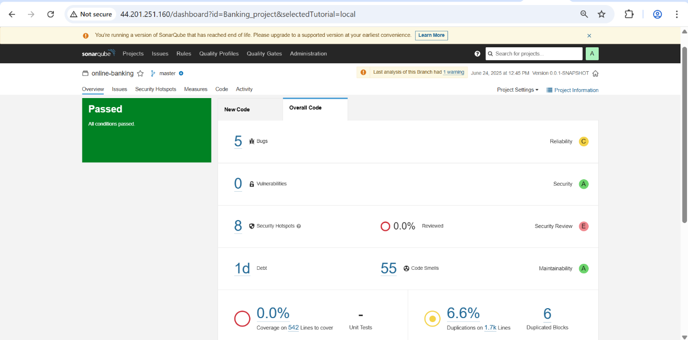

**5.2. Trivy (Container Image Vulnerability Scanning)**

* **Purpose**: Trivy is a comprehensive and easy-to-use open-source vulnerability scanner specifically for container images, file systems, and Git repositories. It identifies known security vulnerabilities in the image's operating system packages and application dependencies.
* **Integration**: As detailed in the build phase of buildspec.yml, Trivy scans the Docker image immediately after it's built and tagged, before it's pushed to ECR.
* **Benefits**:
  + **Early Detection**: Identifies vulnerabilities early in the development lifecycle, making them cheaper and easier to fix.
  + **Automated Security Check**: Automates the security scanning process, ensuring consistent checks without manual intervention.
  + **Comprehensive Coverage**: Scans various layers of your image, including the base OS and programming language-specific dependencies.
  + **Artifact Generation**: The scan report (trivy-reports/report.txt) provides actionable insights into discovered vulnerabilities, including their severity, package affected, and potential remedies.
* **Integration in Pipeline**: By setting --exit-code 0 in the buildspec.yml, the pipeline collects the scan report but doesn't halt the build if vulnerabilities are found. While this ensures continuous delivery, for production-grade security, it's highly recommended to configure --exit-code 1 (and remove || true) to enforce a "fail-fast" policy, stopping the build if critical or high-severity vulnerabilities are detected.

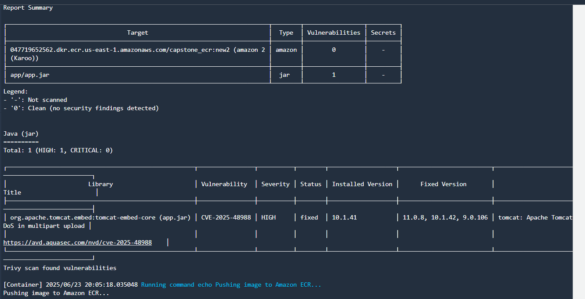

**6. Kubernetes Deployment Manifests (k8s/deployment.yaml, k8s/service.yaml)**

Kubernetes deployment is managed through declarative manifest files, which define the desired state of the application within the cluster. These YAML files specify how the application's containers should run, be exposed, and scale.

**k8s/deployment.yaml**

This manifest defines a **Kubernetes Deployment**, a controller that guarantees a specific number of identical replicas of your application are running at all times. It is responsible for managing the lifecycle of your application's pods, including updates and rollbacks.

* **Image Reference:** It references the Docker image to be deployed, with the image URI being programmatically updated by sed during the CodeBuild post_build phase to point to the correct image in ECR.
* **Pod Specifications:** The manifest details crucial configurations for the application's pods, such as:
  + The desired number of replicas to ensure availability and handle traffic.
  + Container ports that the application listens on.
  + Environment variables, which can include sensitive information like the RDS_ENDPOINT, dynamically passed from the build environment.
  + Resource requests and limits for CPU and memory, which are essential for efficient scheduling and preventing resource starvation.
  + Health probes (e.g., liveness and readiness probes) to ensure the application is healthy and responsive.

**k8s/service.yaml**

This manifest defines a **Kubernetes Service**, which provides a stable and consistent network endpoint for accessing the application's pods. It decouples the application's frontend from the backend pods, abstracting away their dynamic IP addresses.

* **Traffic Routing:** It specifies how incoming network traffic is distributed to the application's pods, including the mapping of service ports to container ports.
* **Service Type:** The type of Service determines its accessibility. The manifest can define the service as:
  + **ClusterIP**: For internal cluster-only access.
  + **NodePort**: To expose the service on a static port on each node's IP.
  + **LoadBalancer**: To integrate with a cloud provider's load balancing service (like an **AWS Application Load Balancer**), exposing the application to external traffic.

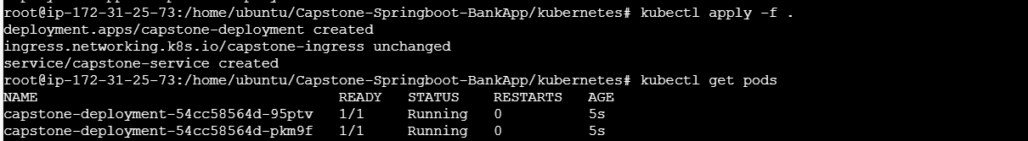



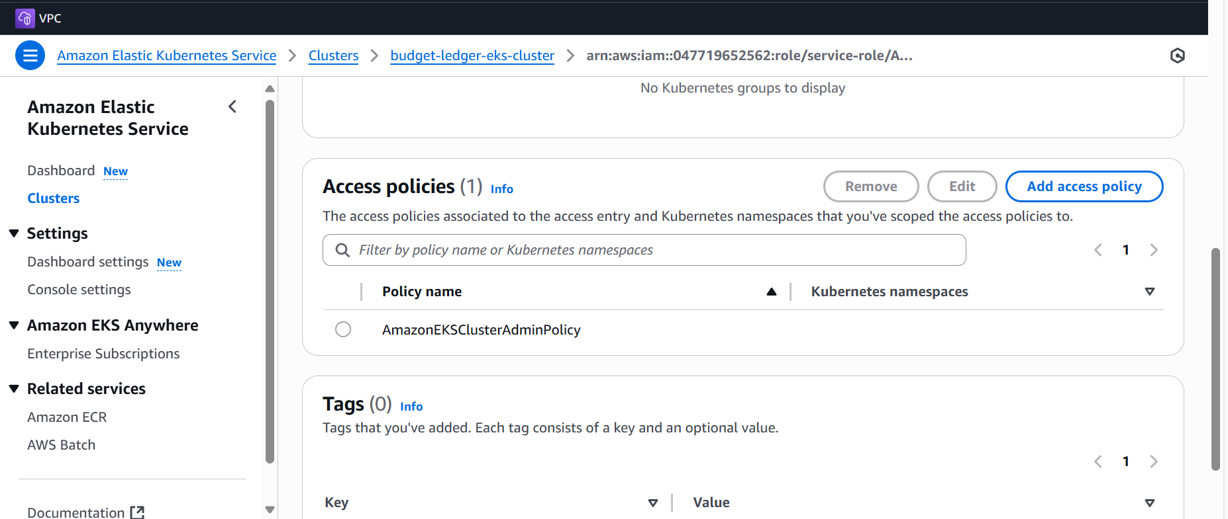

These manifests are generated as build artifacts, ready to be applied to your EKS cluster using **kubectl apply -f k8s-out/.**

**7. Database Structure and Administration**

The system employs a **MySQL** database for storing application data, with **db** overseeing schema versioning and migration processes.

* **Example Data:**  
  The database screenshots illustrate sample records. For instance, the role table contains values such as ROLE_ID and BALANCE. Additionally, users like "Admin" and "Busadd" are visible, demonstrating the existence of a basic user authentication and role management system.
* **Schema Management with Flyway:**  
  The project integrates flyway-mysql to manage database migrations. This ensures all database modifications are tracked through version-controlled scripts, promoting consistency and reliability of the database structure across different deployment environments

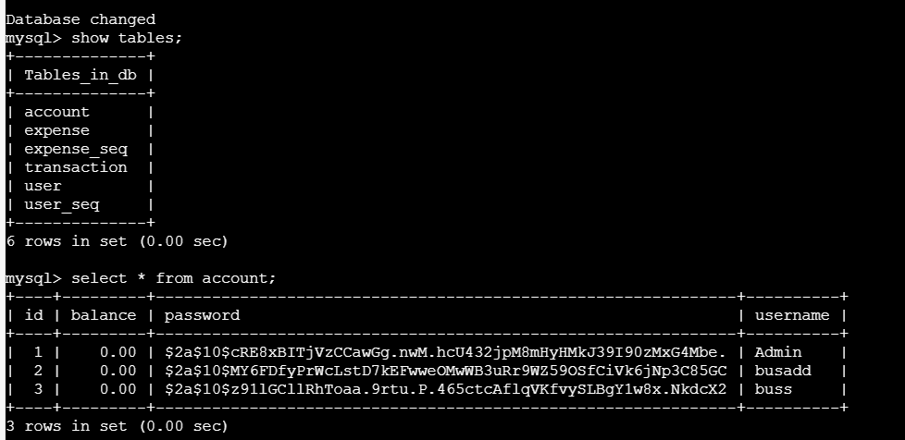

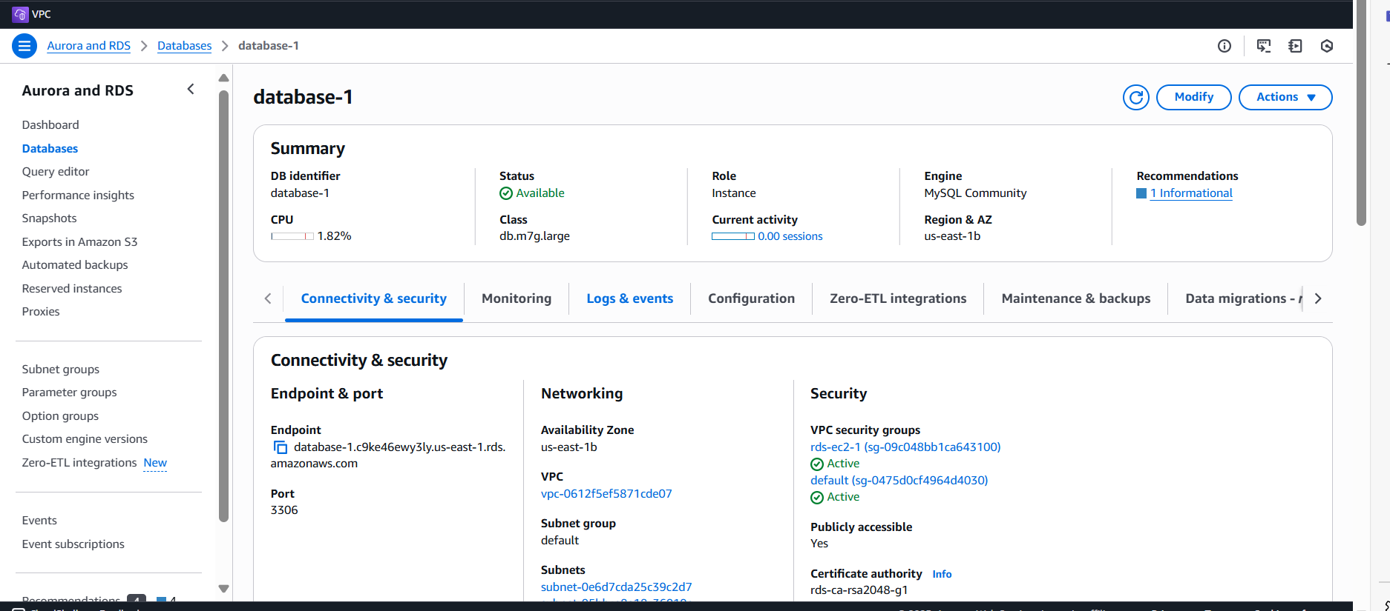

1. **CLOUDFORMATION DEPLOYMENT**

**AWS CloudFormation** is utilized in this project to automate the provisioning and management of cloud infrastructure in a secure, repeatable, and scalable manner. It allows defining the entire AWS environment — including VPCs, subnets, security groups, EC2 instances, RDS databases, EKS clusters, and more — as code using YAML or JSON templates.

**Key Benefits for the Project:**

* **Infrastructure as Code (IaC):**  
  CloudFormation templates ensure that the infrastructure is version-controlled, consistent, and can be replicated across different environments (development, staging, production) without manual intervention.
* **Automated Resource Deployment:**  
  Complex environments such as VPC networking, EKS clusters, RDS databases, and supporting components are provisioned automatically, reducing human error and setup time.
* **Simplified Multi-Region Setup:**  
  For projects requiring **high availability** or **disaster recovery**, CloudFormation can deploy resources across multiple AWS regions using **StackSets**, ensuring uniform infrastructure configuration.
* **Integrated with CI/CD:**  
  CloudFormation templates can be integrated into CI/CD pipelines (such as AWS CodePipeline) to automate infrastructure deployment alongside application delivery.
* **Consistent and Reliable Infrastructure:**  
  Any infrastructure changes are tracked, tested, and deployed in a controlled manner, making the project environment stable and easy to manage.

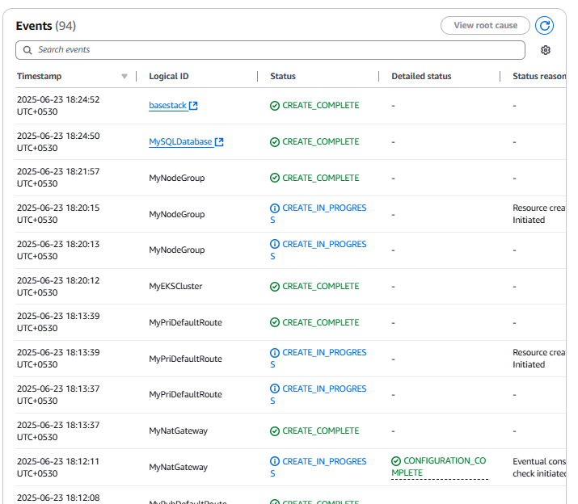

**8.1 Codebuild for the Us-east-1 Region**

- Creating the Code Build for my Budgetledger project.

- Providing the Github as the source provider for the build.

Using the Buildspec.yml file where the pipeline flow for the Sonarqube, Trivy, ECR, ArgoCd, and code deploy can be done.

Code build has been created and succeeded.

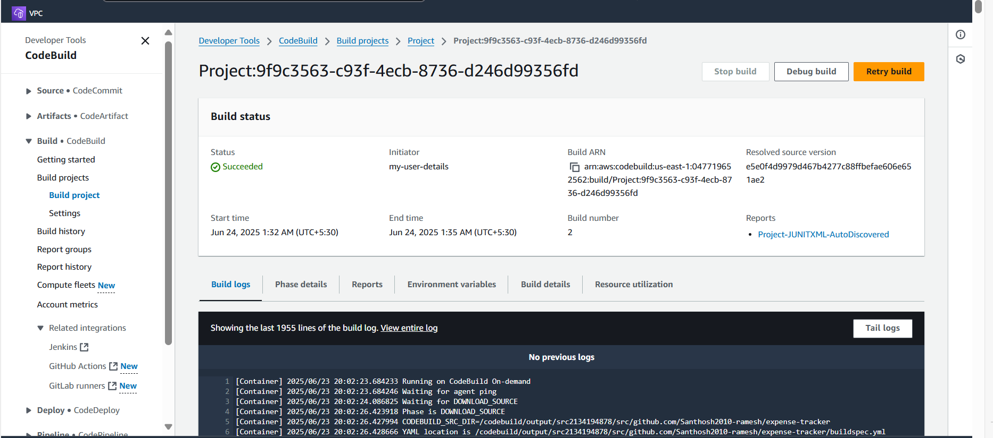

**Typical Pipeline**

Github → SonarQube Code Scan → Build Image → Trivy Image Scan → Deploy to Kubernetes

The Code Build is done successfully.

**AWS Codepipeline**

**-**Added the Codepipeline with the source as github.

-Adding the Buildstage for the codepipeline as codebuild.

-Add the deploy stage to the EKS provider

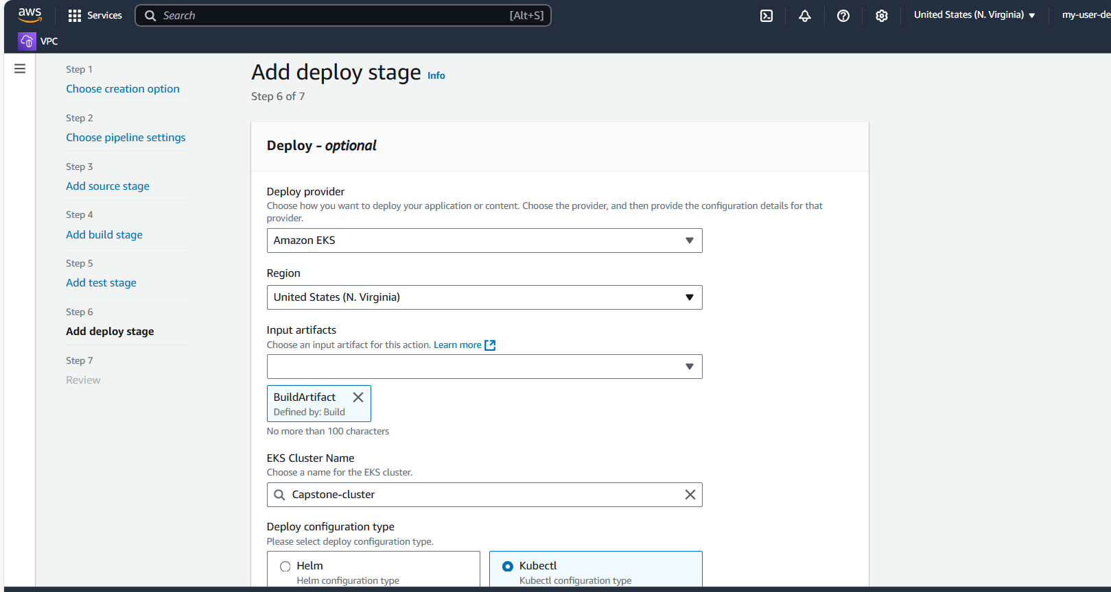

-Adding all the security groups and subnets.

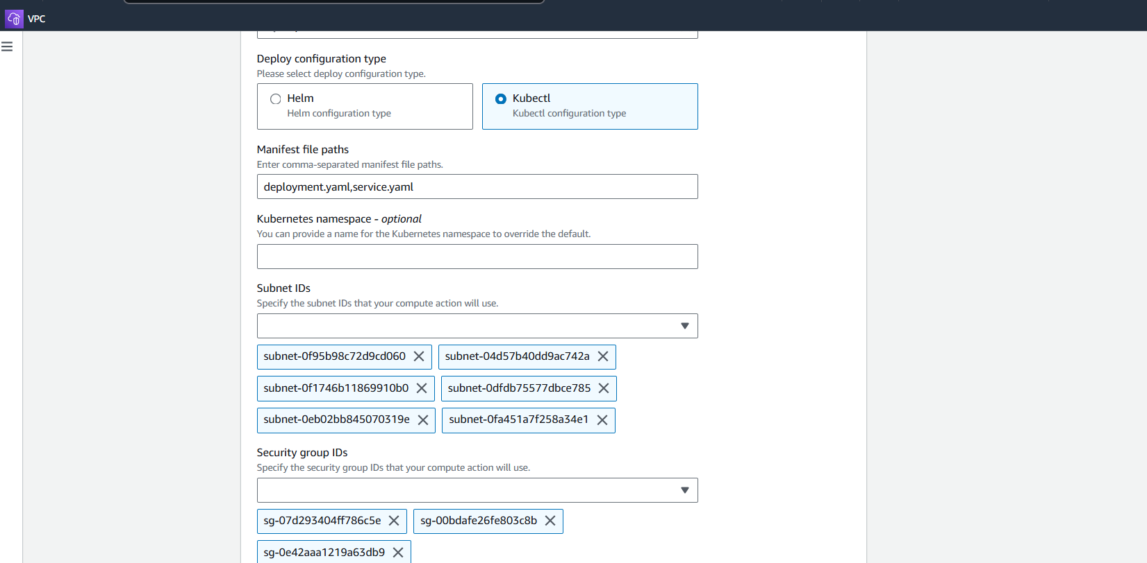

The Pipeline works fine in the us-east-1 region.

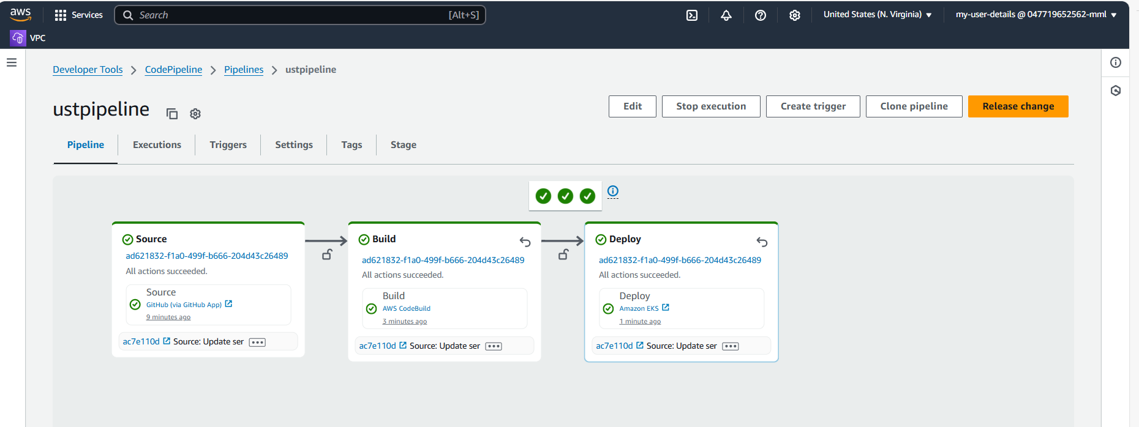

Accessing the Region 1 – ue-east-1 Application through the Load Balancers.

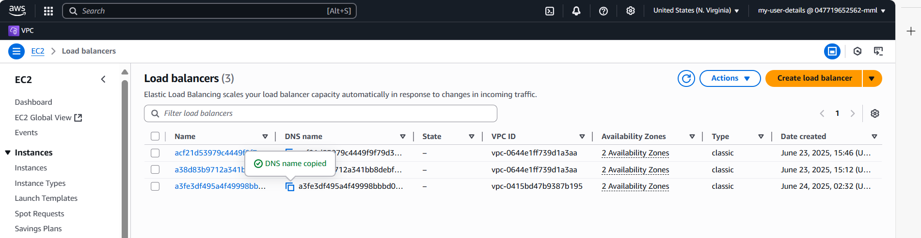

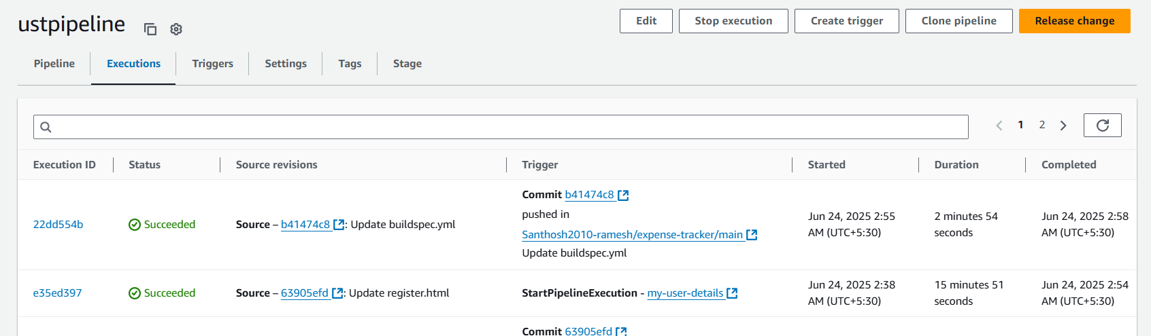

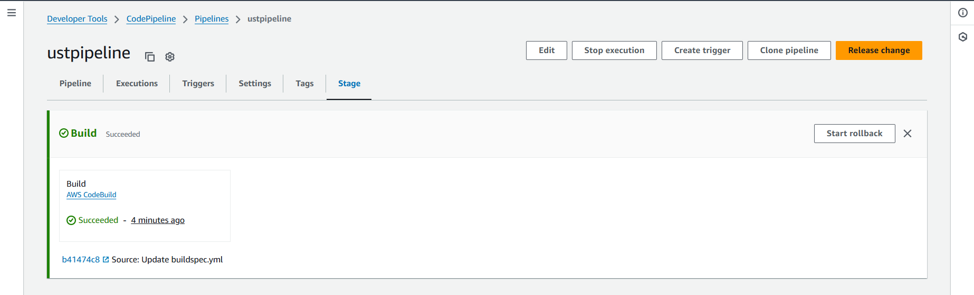

**8.2 Terraform deployment in us-west-1 using codepipeline.**

-Initialized the terraform script.

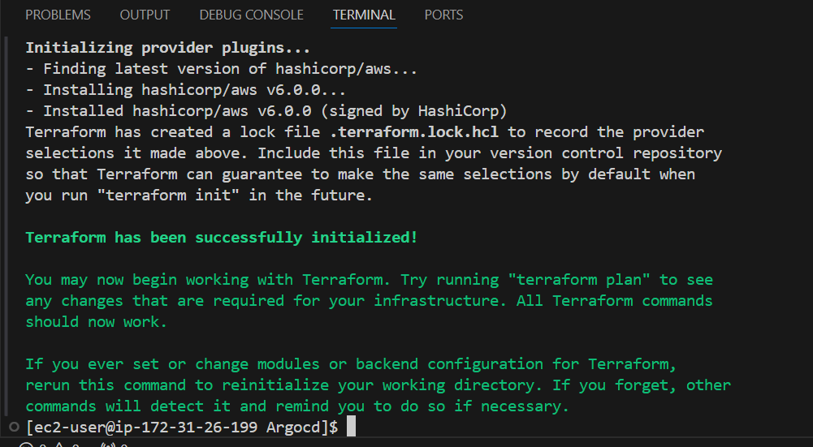

-Planning the terraform resources.

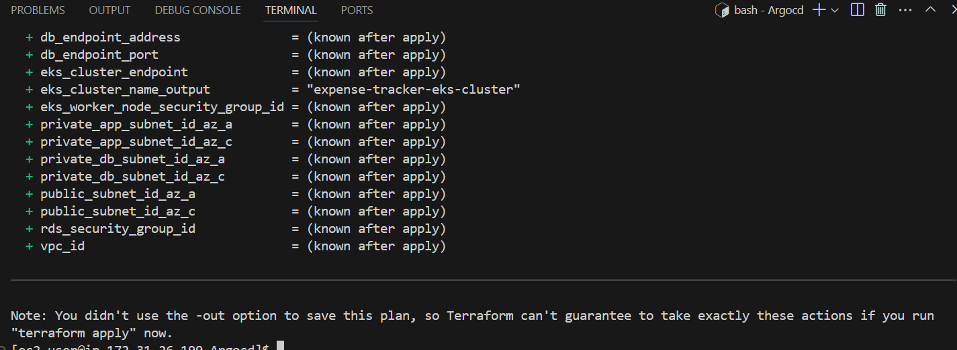

-Apply the resources

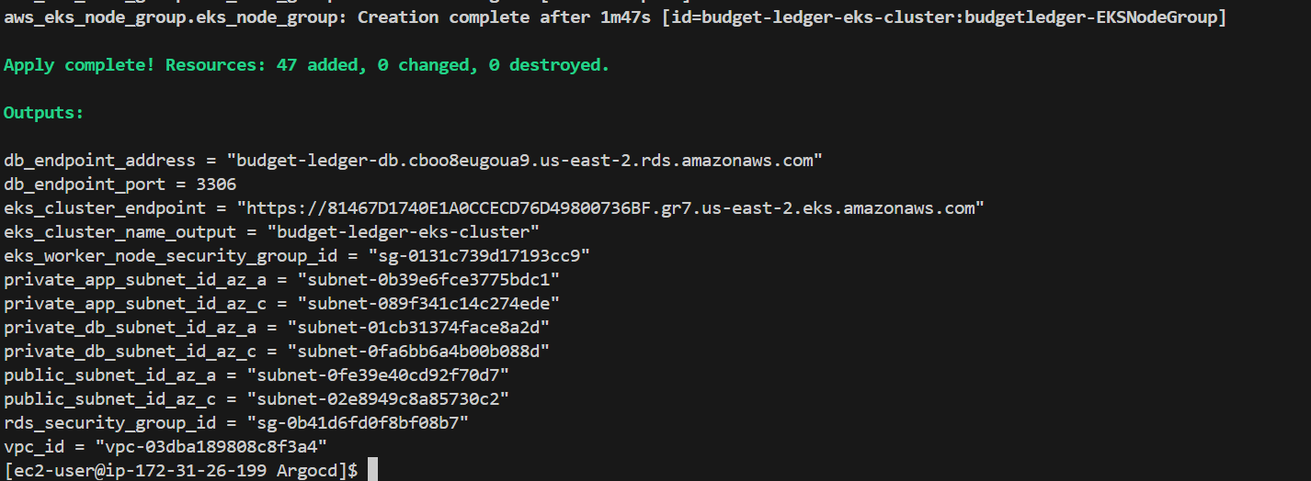

Codebuild for the terraform us-east-2 region

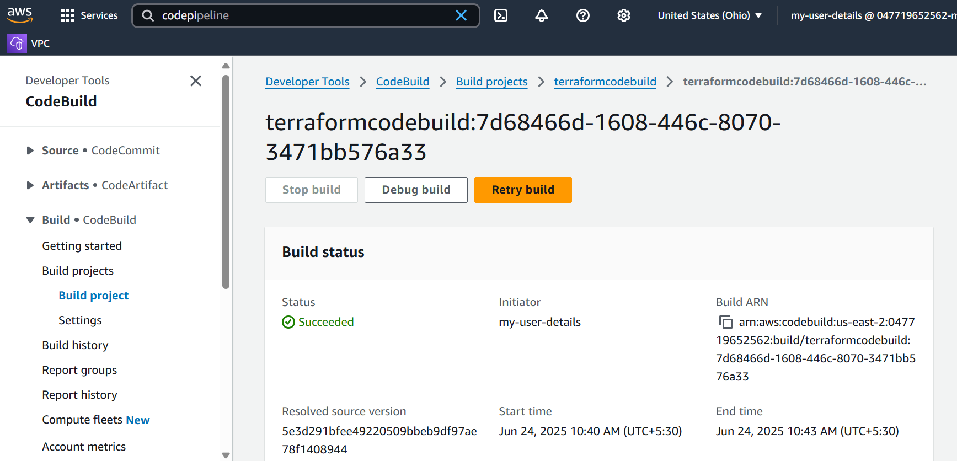

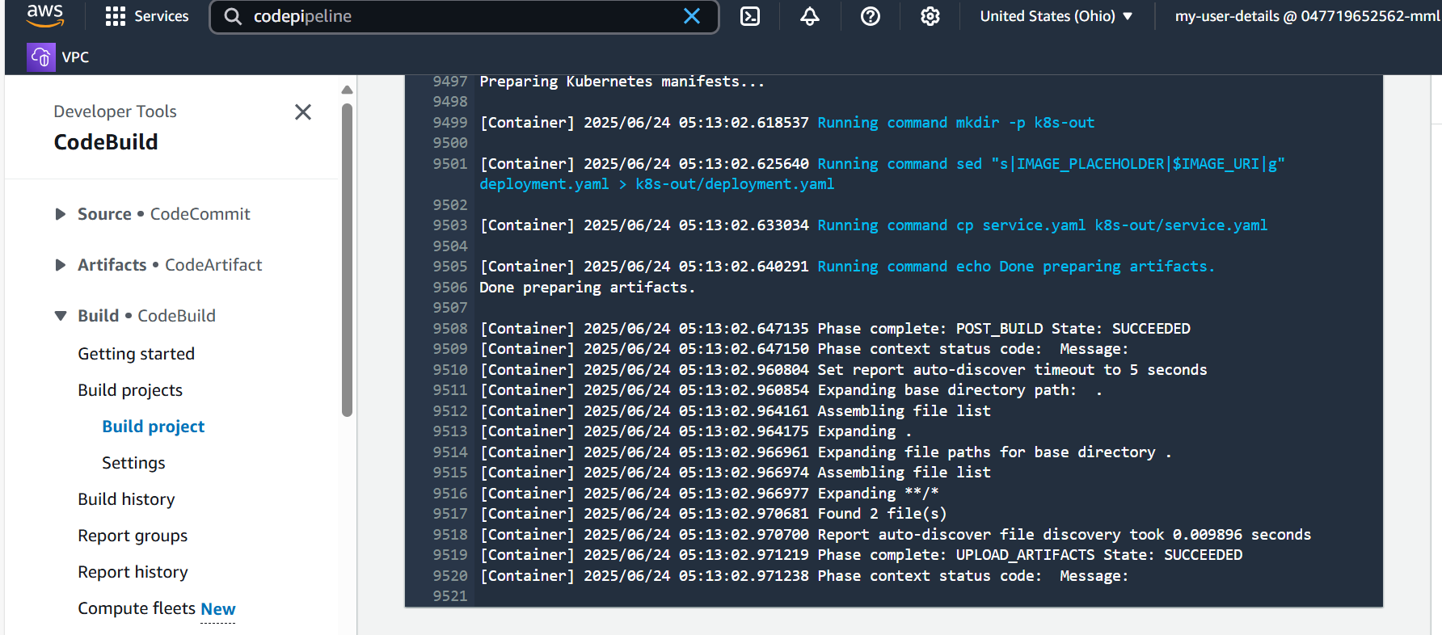

**CodePipeline in Terraform**

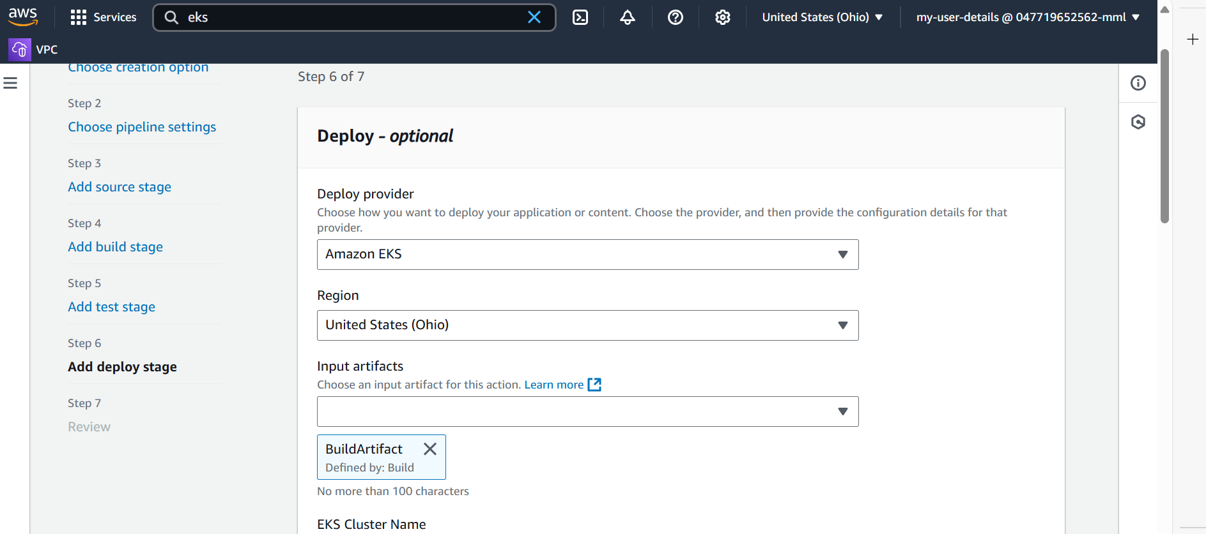

After the codepipeline build give accesspolicy for the pipeline for the EKS cluster deployment of our application.

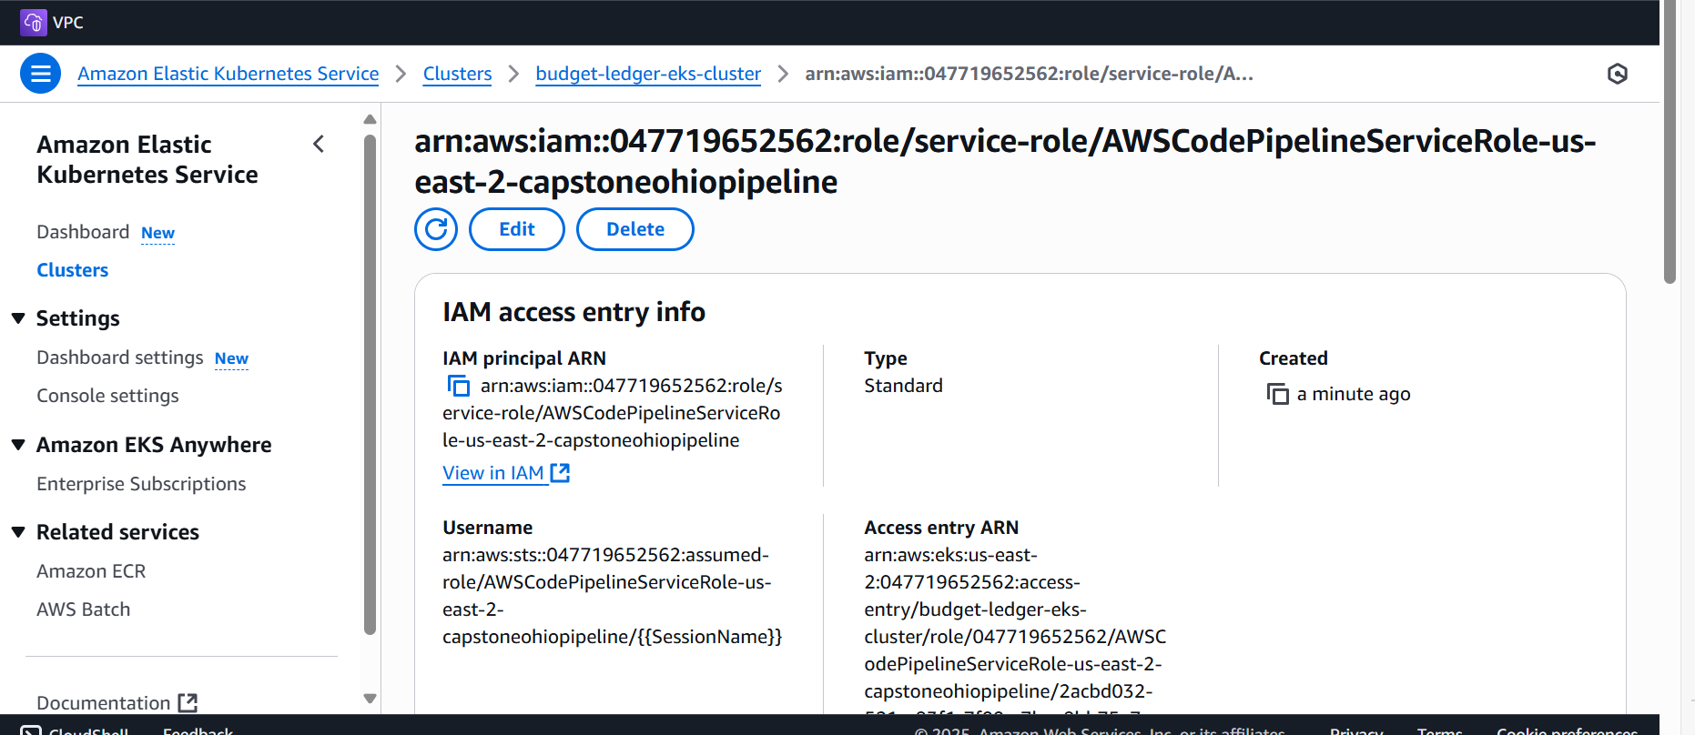

Application Deployment in the Us-east-2 Region (ohio)

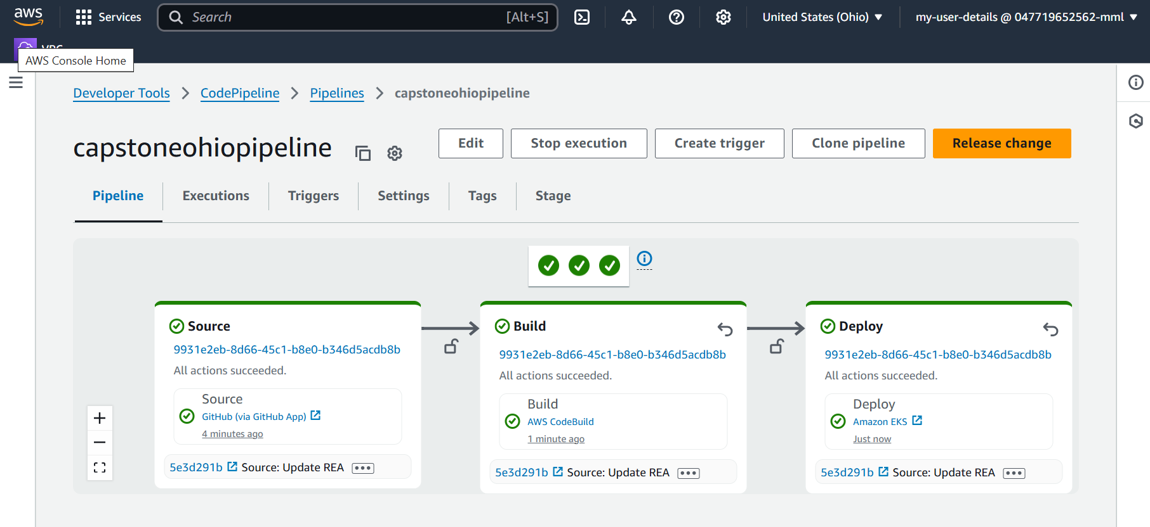

**9. Multi-Region Disaster Recovery and High Availability with Route 53**

An essential component of this project is the deployment of a multi-region architecture, utilizing Amazon Route 53 to manage global traffic distribution and enhance disaster recovery capabilities.

* Cross-Region Application Load Balancers (ALBs):  
  Route 53 is configured to distribute traffic across Application Load Balancers (ALBs) deployed in multiple AWS regions, ensuring global users can access the application efficiently.
* Route 53 Failover Mechanism:  
  The system uses Route 53's failover routing policy, designed to automatically divert traffic to a secondary region if the primary region encounters downtime. This approach guarantees minimal service disruption.
* Health Monitoring:  
  Route 53 continuously performs health checks on key resources, such as ALBs or other application endpoints in each region. If a resource becomes unhealthy, traffic is redirected accordingly.
* Custom Domain Integration:  
  The application is available via a dedicated domain, for example, http://srikar.com, with sub-paths like srikar.com/em directing users to the frontend. Domain name resolution and traffic management are entirely handled by Route 53.
* Seamless Regional Failover:  
  In case of a regional outage or disaster scenario, user requests are automatically routed to healthy infrastructure in another region, eliminating the need for manual intervention and ensuring continuous service.
* Enhanced High Availability and Disaster Recovery:  
  By adopting a multi-region setup with intelligent DNS failover, the project achieves strong fault tolerance, high availability, and resilience, making the online banking system capable of withstanding regional failures or disruptions.
* Buying the domain name: santhoshramesh.com
* Verifying the domain.
* Adding the Application load balancer for the us-east-1 region as the endpoint.

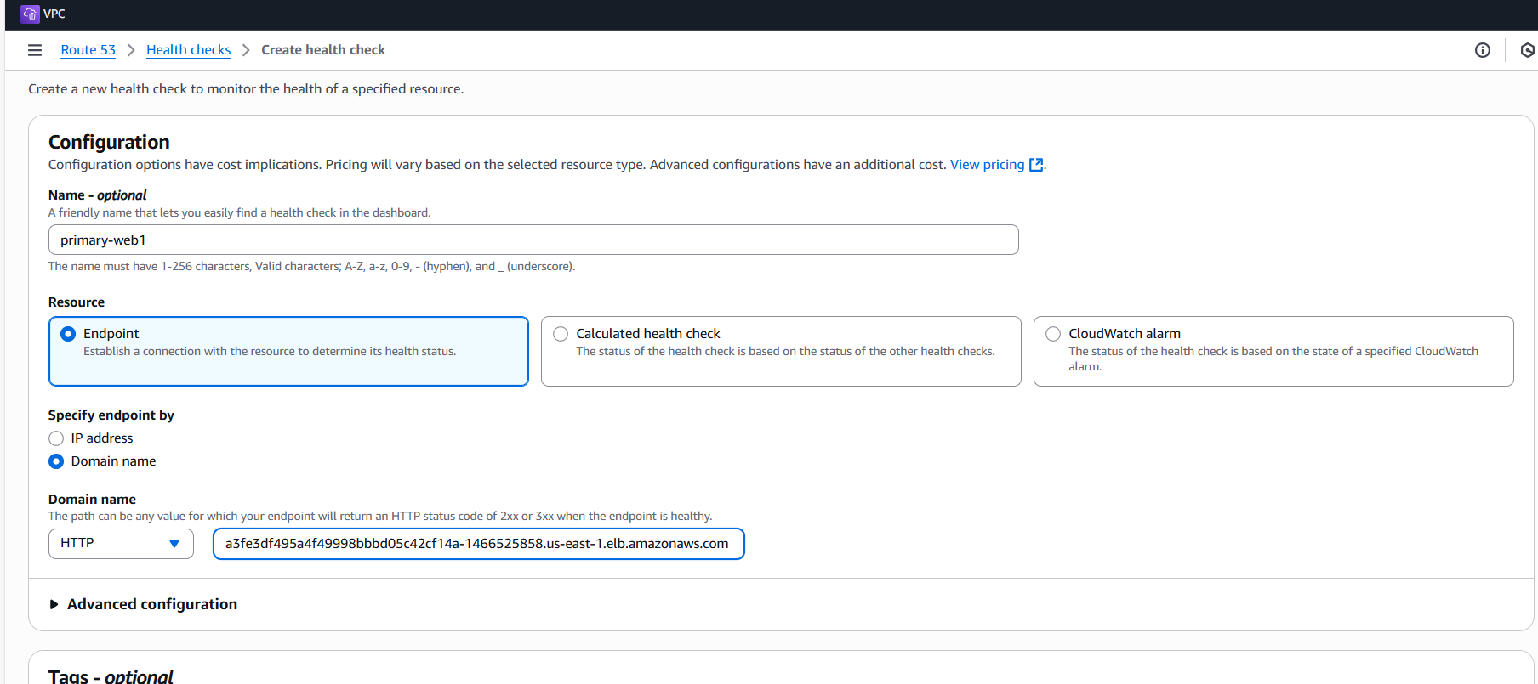

* Adding the Application load balancer for the us-east-2 region as the endpoint.

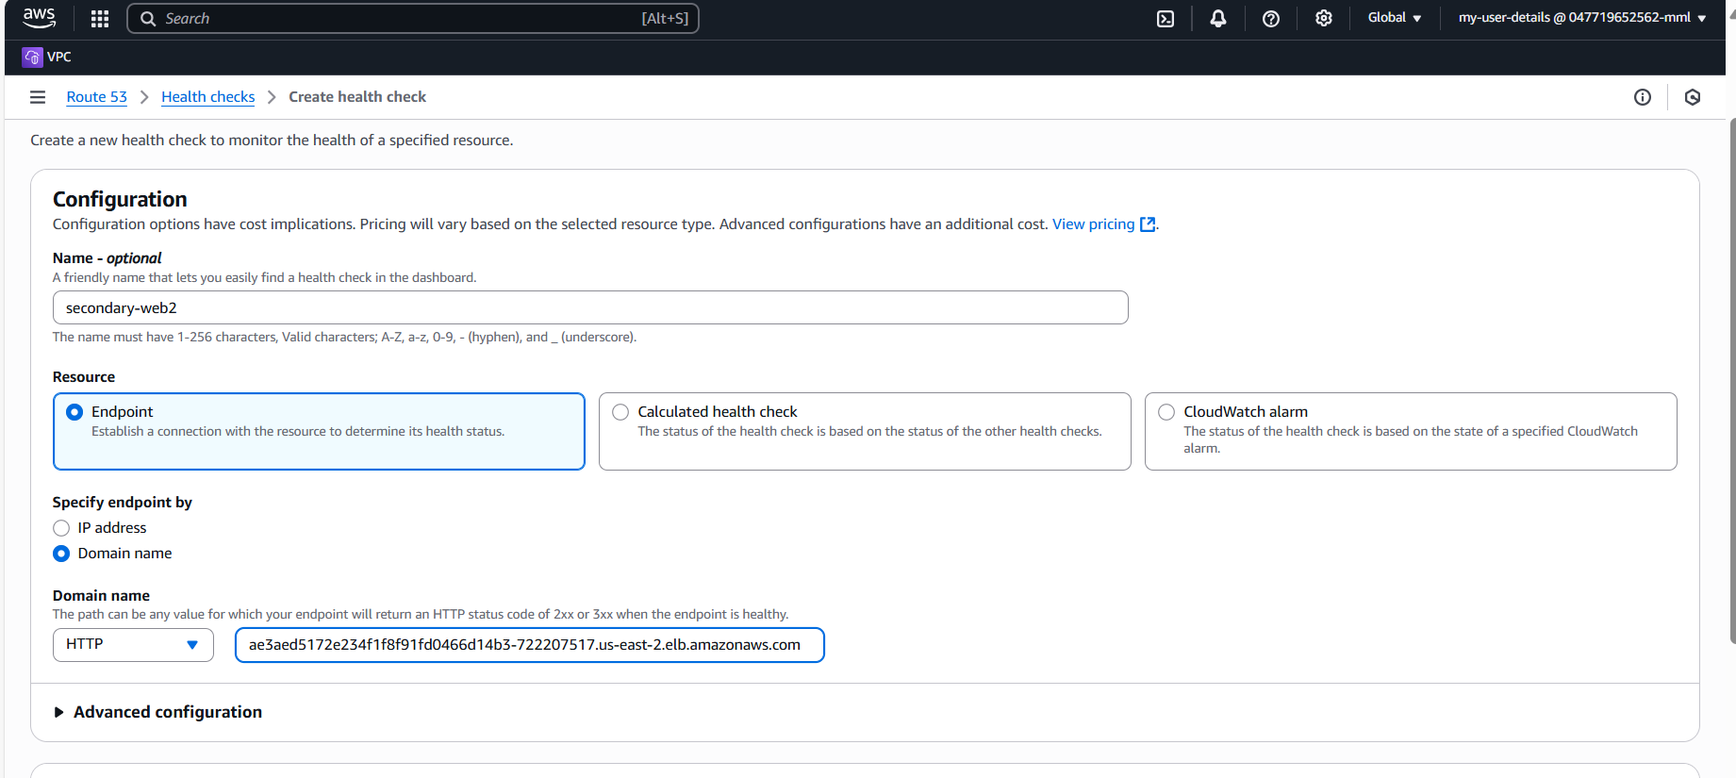

* Checking the Health checks.

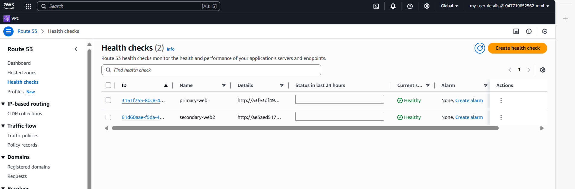

**-**Hosted Zone Created for the domain.

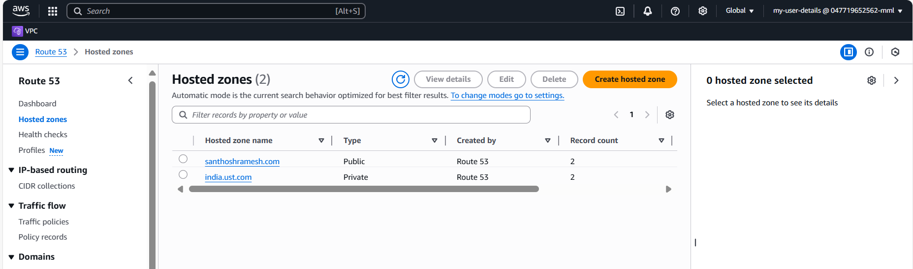

* Requests is successful for the route.

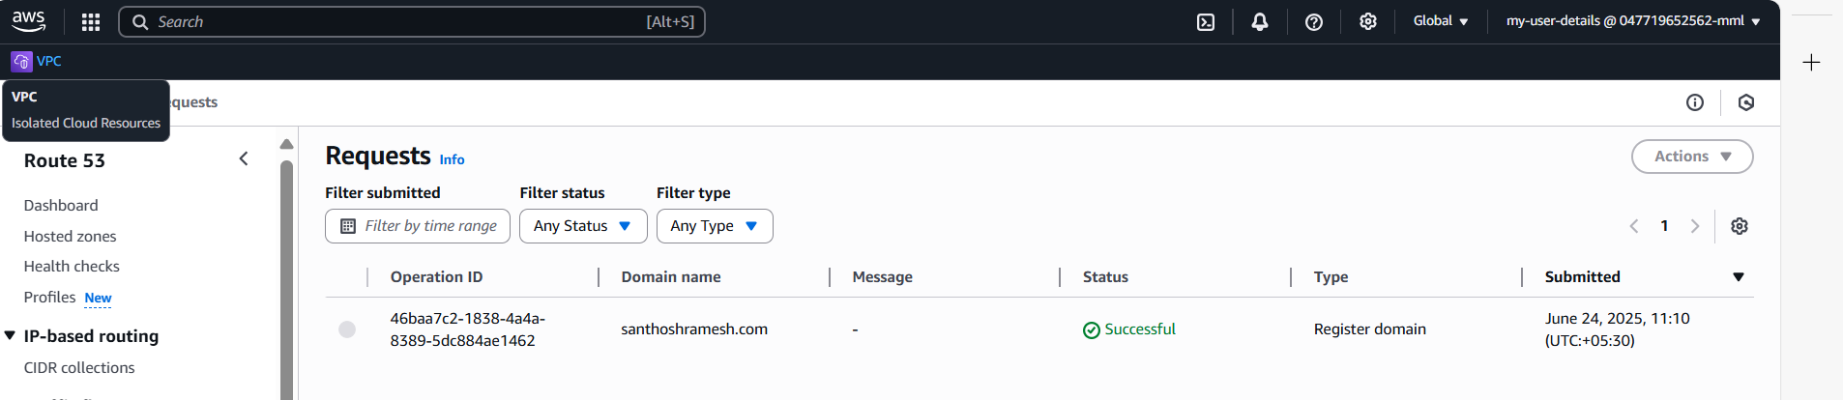

* Creating the record for the route traffic to the alias hosted zone.
* Providing the Routiing policy as Failover.

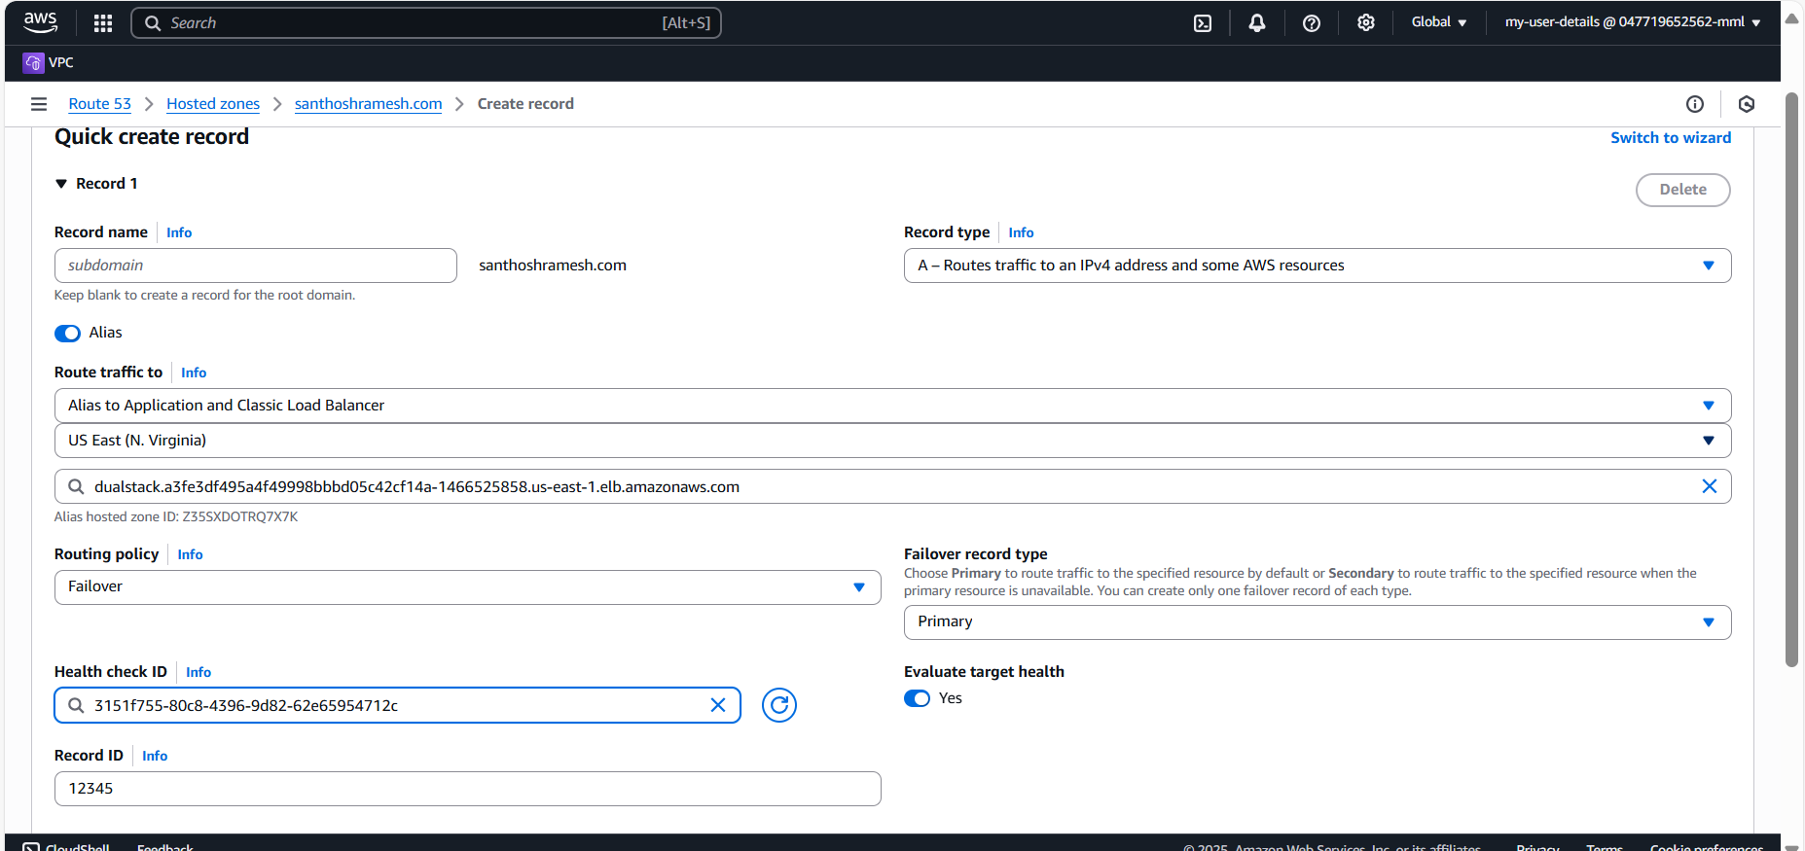

-Creating a secondary failover routing.

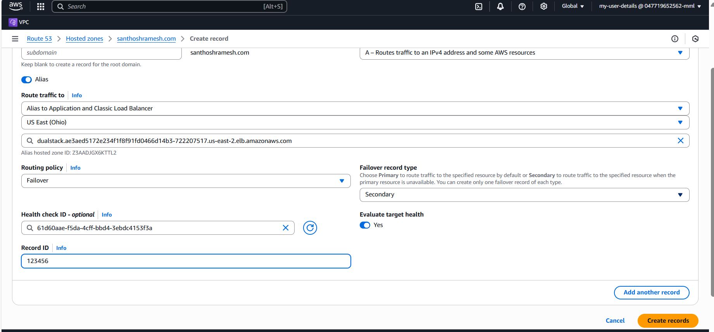

In this project, my Budget Ledger application runs inside Kubernetes Pods, which host the application containers. Services expose these Pods, allowing stable communication within the cluster and external access when needed. This setup ensures the Budget Ledger Pods and Services are scalable, accessible, and highly available.

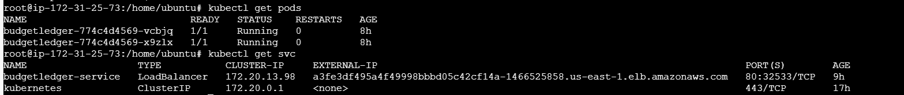

**10. ArgoCD Deployment Summary for Budget Ledger Project.**

ArgoCD is implemented in this project to enable continuous deployment of Kubernetes resources for the Budget Ledger application. It automatically syncs and deploys the latest manifest files, ensuring that Budget Ledger Pods and Services are always up to date with the latest configurations. With ArgoCD, any changes pushed to the Git repository are continuously deployed to the cluster, providing reliable, consistent, and automated delivery for the application infrastructure.

-Install Argo CD

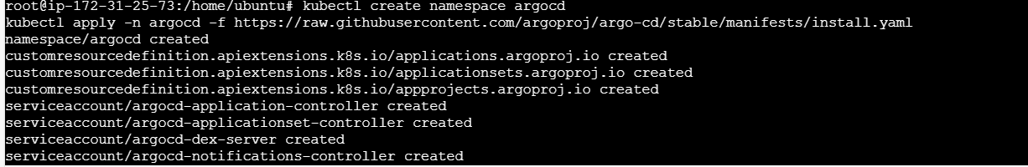

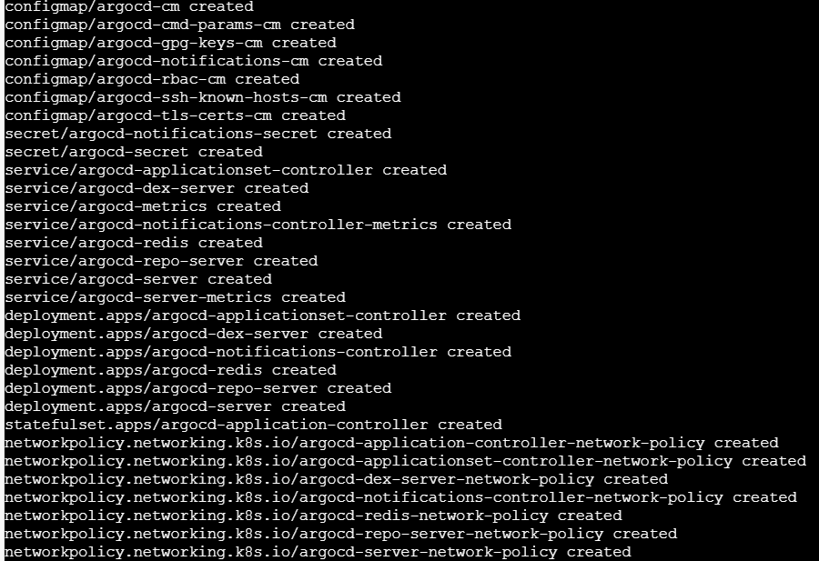

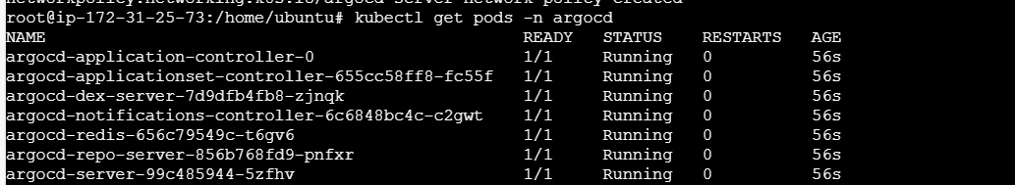



-Accessing the Argo CD API Server

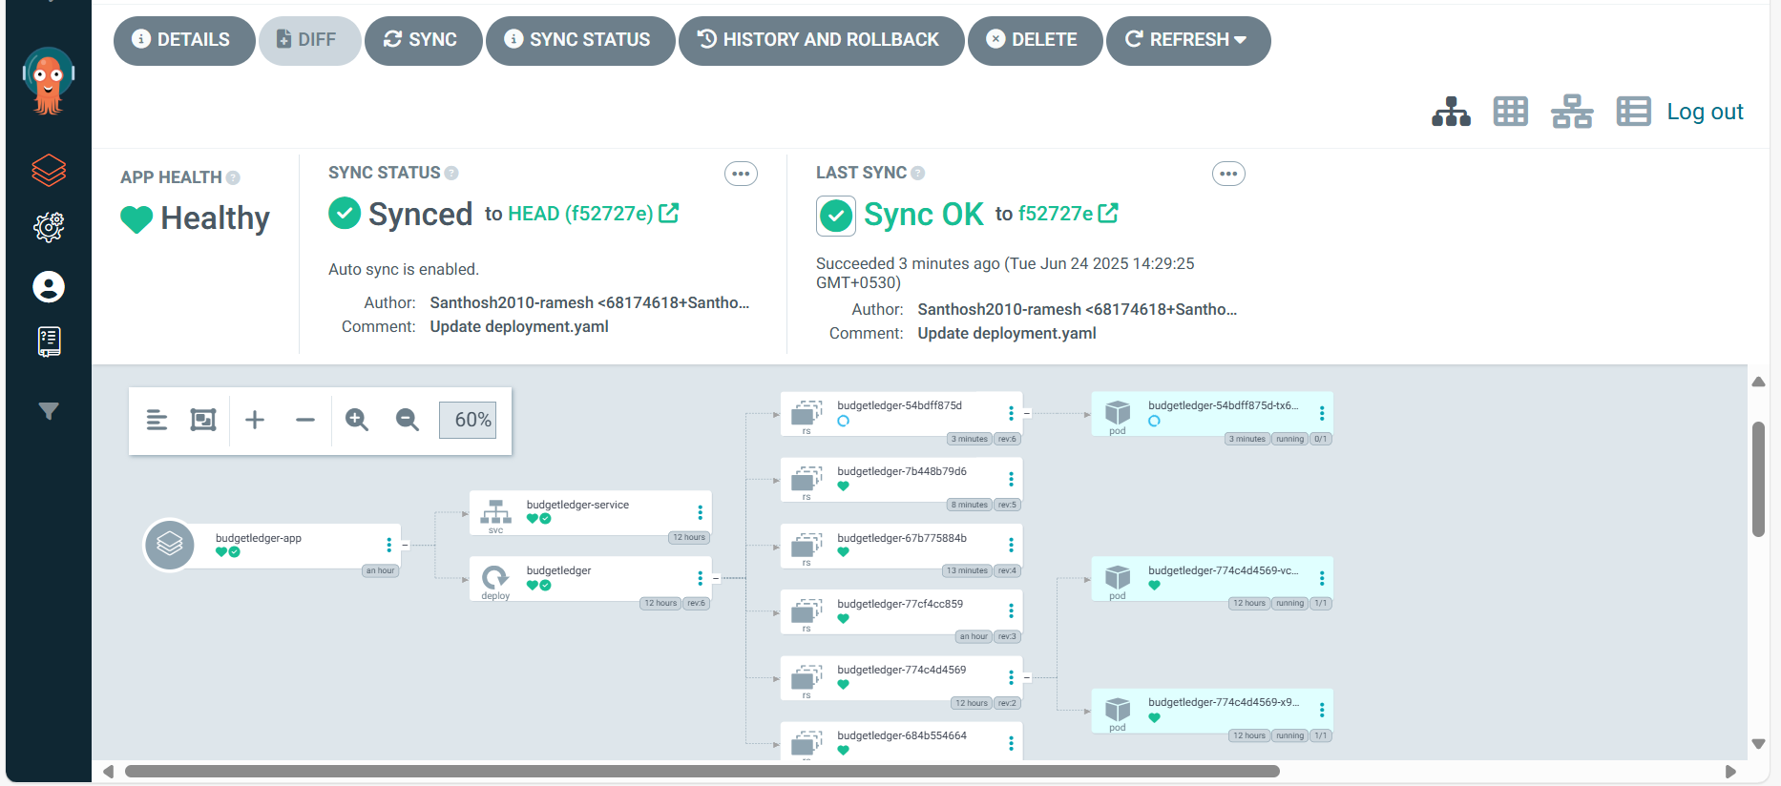

**11. Event-Driven Automation with Amazon EventBridge**

Amazon EventBridge is a vital component of the system, enabling real-time, event-driven workflows and automation across the architecture.

* Scalable Event-Driven Architecture:  
  EventBridge facilitates building responsive and scalable applications by routing events from various AWS services or custom sources to configured targets.
* Custom Event Rules:

Specific EventBridge rules are created to monitor particular events, whether they originate from AWS resources or custom applications, allowing precise detection of system changes.

* Lambda Integration for Automation:  
  These event rules can trigger AWS Lambda functions, providing serverless compute to handle automated tasks, such as data processing, resource updates, or system responses.
* SNS Notifications for Alerts:  
  Events can also be forwarded to Amazon SNS (Simple Notification Service) topics to broadcast alerts to subscribers via channels like email or SMS. For example, an SNS topic with the ARN arn:aws:sns:us-east-1:026090550003:Capstone_topic confirms that automated notifications are configured, as shown in Image 12.
* Real-Time Monitoring and Automated Actions:

This setup enables immediate alerts for critical events and triggers automated workflows, ensuring the system responds proactively to issues or operational requirements.

* Creating the Event Pattern for the Service.

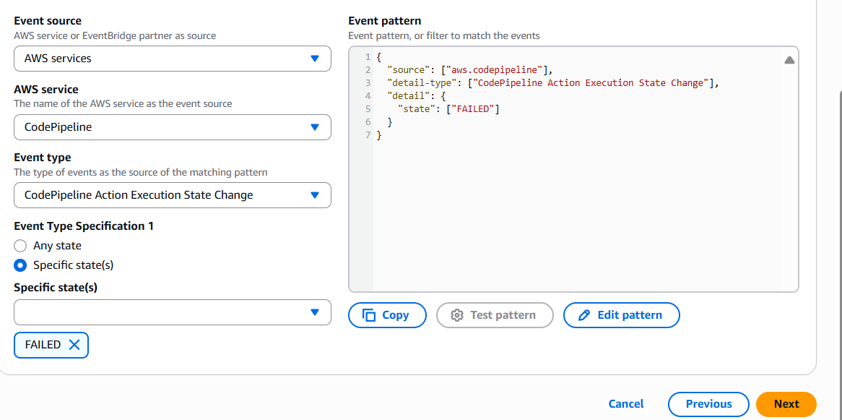

-Create SNS

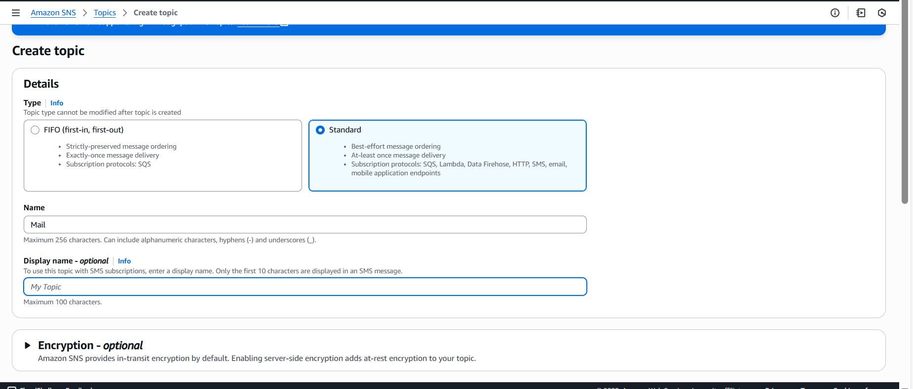

-Create a Subscription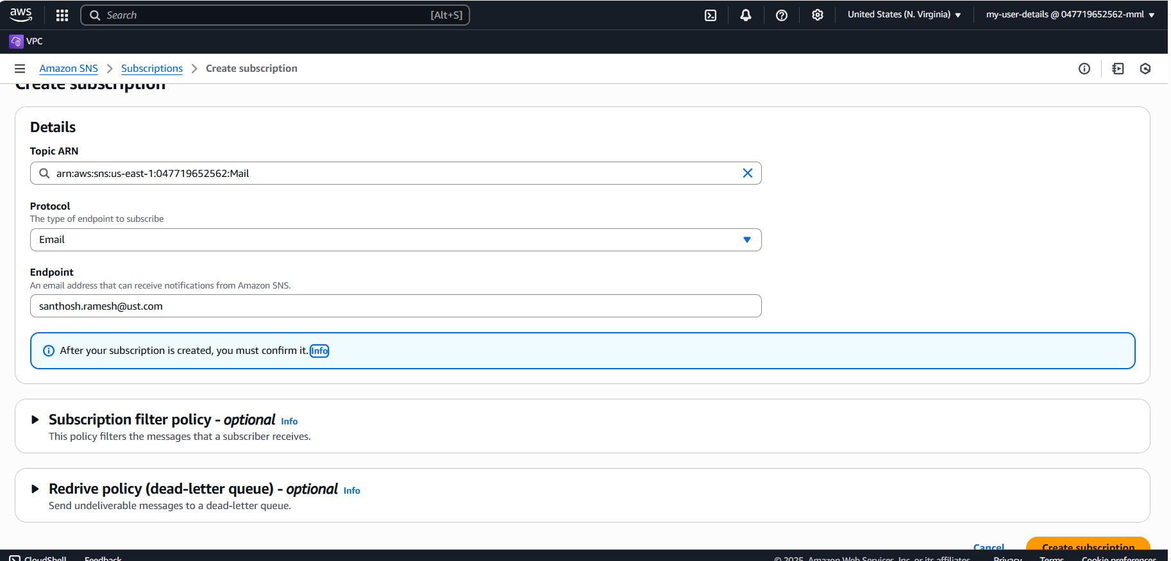

-Email confirmation to be done

-Creating a Lambda Function.

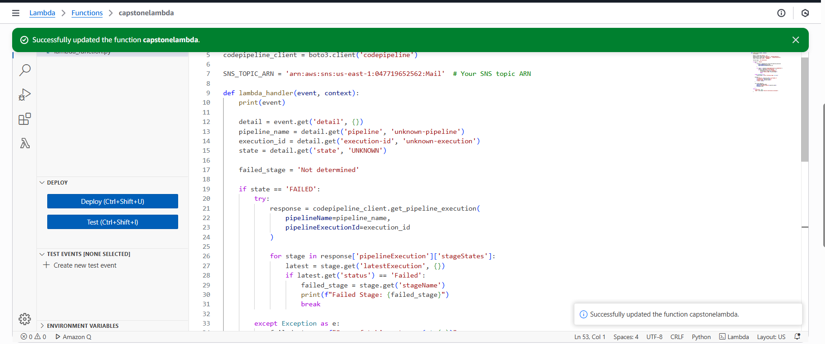

* Add permissions to the role in the lambda function.

**12. Data Protection Using AWS Backup**

AWS Backup is utilized in this project to ensure automated, centralized, and secure backup management for critical AWS resources.

* Unified Backup Control:  
  Provides a centralized interface to manage and monitor backups across multiple AWS services from a single location.
* Scheduled Backup Automation:  
  Backup plans are defined with automated schedules, such as performing backups every 12 hours, as demonstrated by the rds-backup-rule configuration shown in Image 25.
* Customizable Retention Periods:  
  Backup retention settings can be tailored to project needs, for example, retaining backup data for a total period of 35 days (5 weeks).
* Cross-Region Backup Replication:  
  Supports duplicating backups to different AWS regions to enhance disaster recovery strategies and maintain data availability even during regional outages.
* Secure Backup Vaults:  
  All backups are stored within secure, designated Backup Vaults, such as my-rds-backup-vault, ensuring protection against unauthorized access.
* MySQL Database Recovery:  
  This setup is critical for safeguarding the MySQL database, enabling point-in-time recovery and restoration in case of failures, corruption, or accidental data loss. The online-banking-rds-backup-plan is configured specifically to support this requirement

Creating a rds-backup-rule.

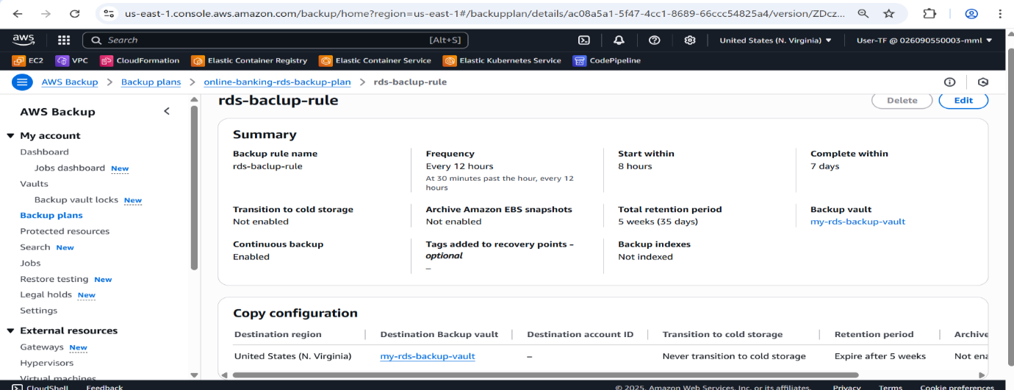

**13. Monitoring and Observability with Amazon CloudWatch and Grafana**

Comprehensive monitoring and observability are essential for ensuring system health, quickly identifying issues, and maintaining performance in modern, cloud-native applications.

**13.1 Amazon CloudWatch**

**Amazon CloudWatch** acts as the primary monitoring and log management service within the AWS ecosystem, providing deep visibility into application and infrastructure health.

* **Key Features:**
  + **Centralized Log Collection:**  
    CloudWatch gathers log data from **EKS pods**, **EC2 instances**, and other AWS resources, offering a unified platform for monitoring application and infrastructure logs.
  + **Resource and Application Metrics:**  
    It captures essential performance indicators such as **CPU usage**, **memory utilization**, **network traffic**, and **disk I/O**, covering both **EKS clusters** (nodes, pods, containers) and **RDS instances**. Images 13 to 16 illustrate these metrics, showcasing CPU utilization, memory trends, and overall cluster health summaries.
  + **Alarms and Notifications:**  
    Alarms can be set for critical metrics, triggering alerts when thresholds are exceeded. For example, Image 13 shows an alarm configured to notify when CPU usage crosses 75%, with alerts sent through **Amazon SNS**.
  + **Real-Time Dashboards:**  
    Customizable dashboards present visual summaries of key system metrics, logs, and cluster states. Examples in Images 14, 15, and 16 demonstrate system performance, resource utilization, and overall cluster health insights.

**Benefits:**

With CloudWatch, the project achieves proactive monitoring, real-time performance visibility, rapid troubleshooting, and enhanced system availability, ensuring the application remains stable and resilient.

-Created the Cloudwatch for the us-east-1 region.

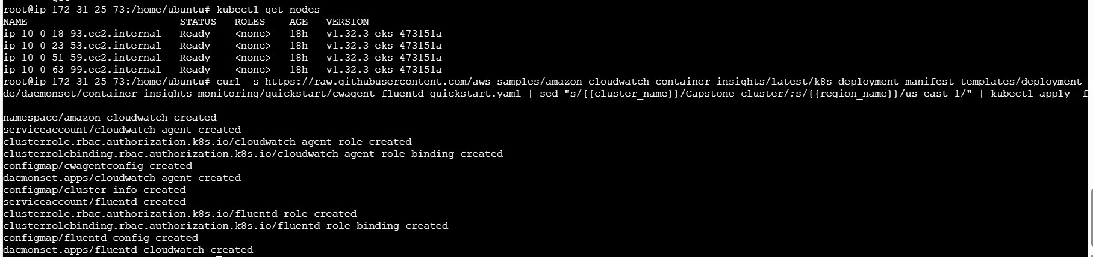

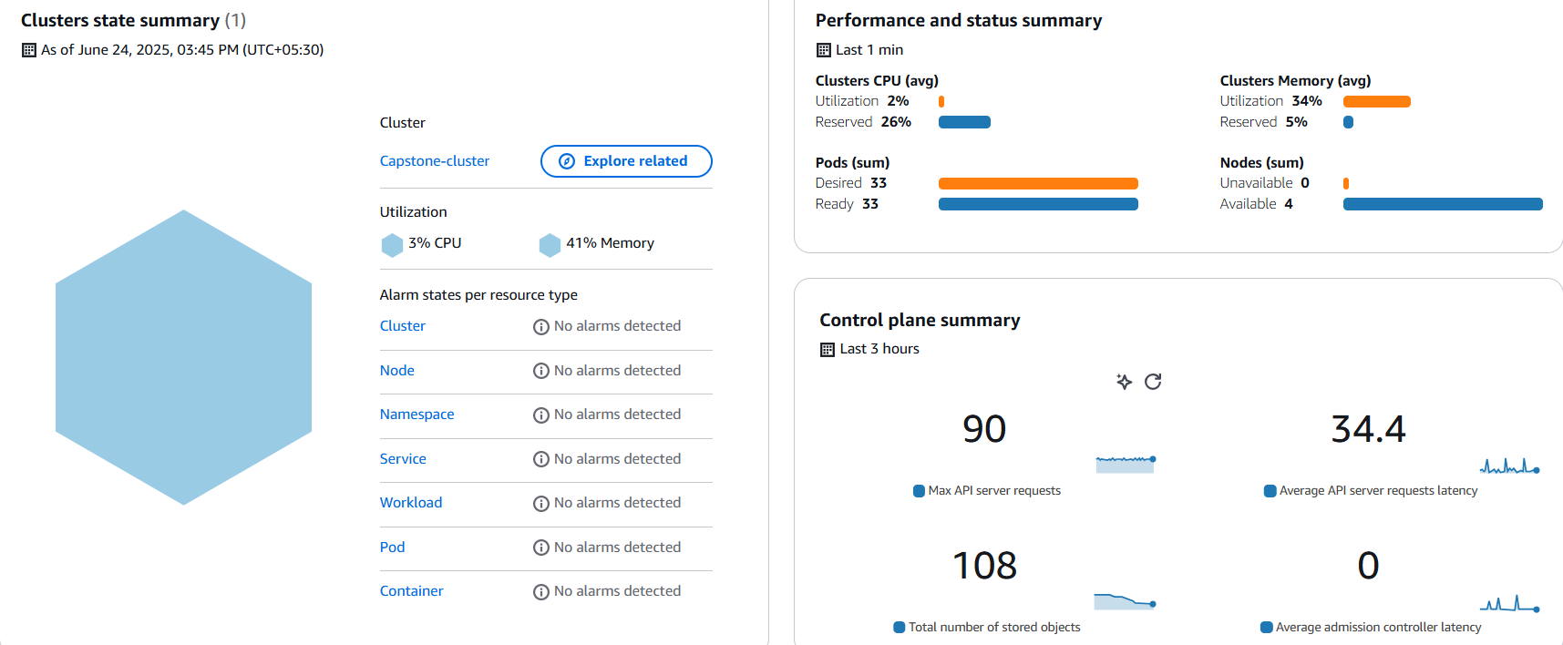

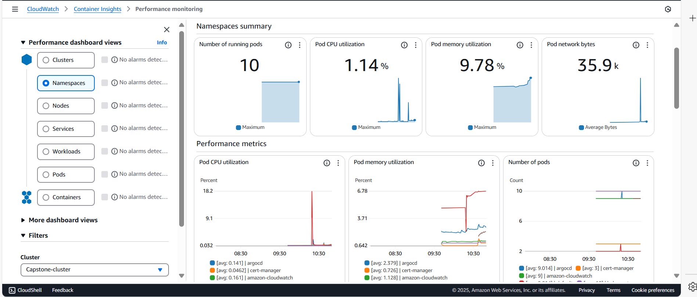

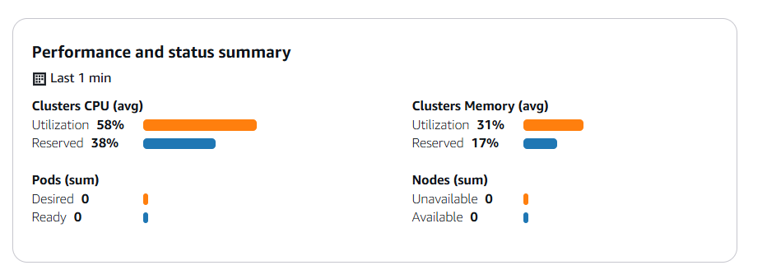

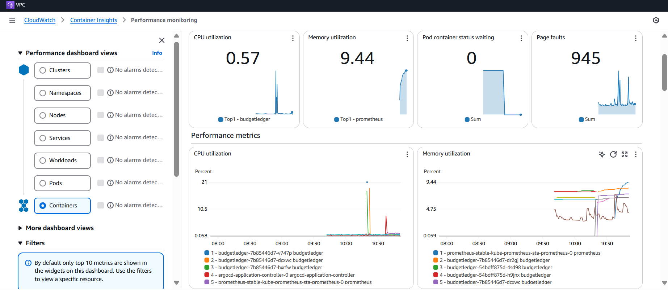

**13.2** **Alarm Notification**

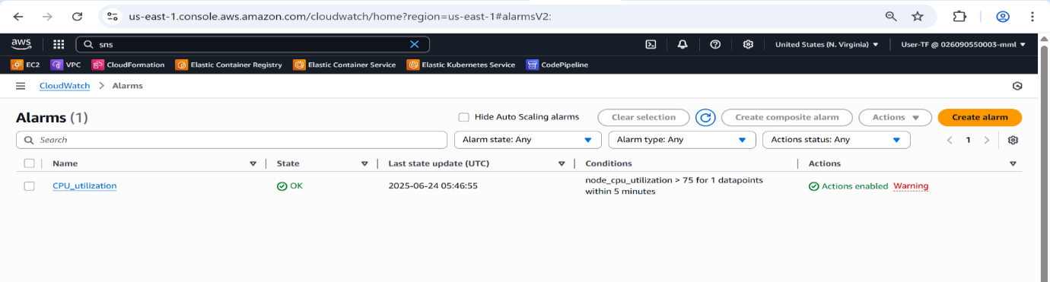

**13.3 Prometheus**

Prometheus is an open source monitoring tool. It provides out-of-box monitoring container orchestration platform.Collects and stores metrics as time-series data, recording information with a timestamp.It is based on pull and collects metrics from targets by scraping metrics HTTP endpoints.

-Installing the Helm Charts.

Helm is a package manager for Kubernetes. A Helm Chart is a collection of files that describe a set of Kubernetes resources. Helm Charts helps you define, install, and upgrade even the most complex Kubernetes application. Charts are easy to create, version, share, and publish.

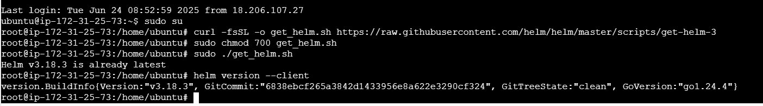

**13. 4 Grafana**

* Grafana is an open source visualization and analytics software.
* It allows you to query, visualize, alert on, and explore your metrics no matter where they are stored.

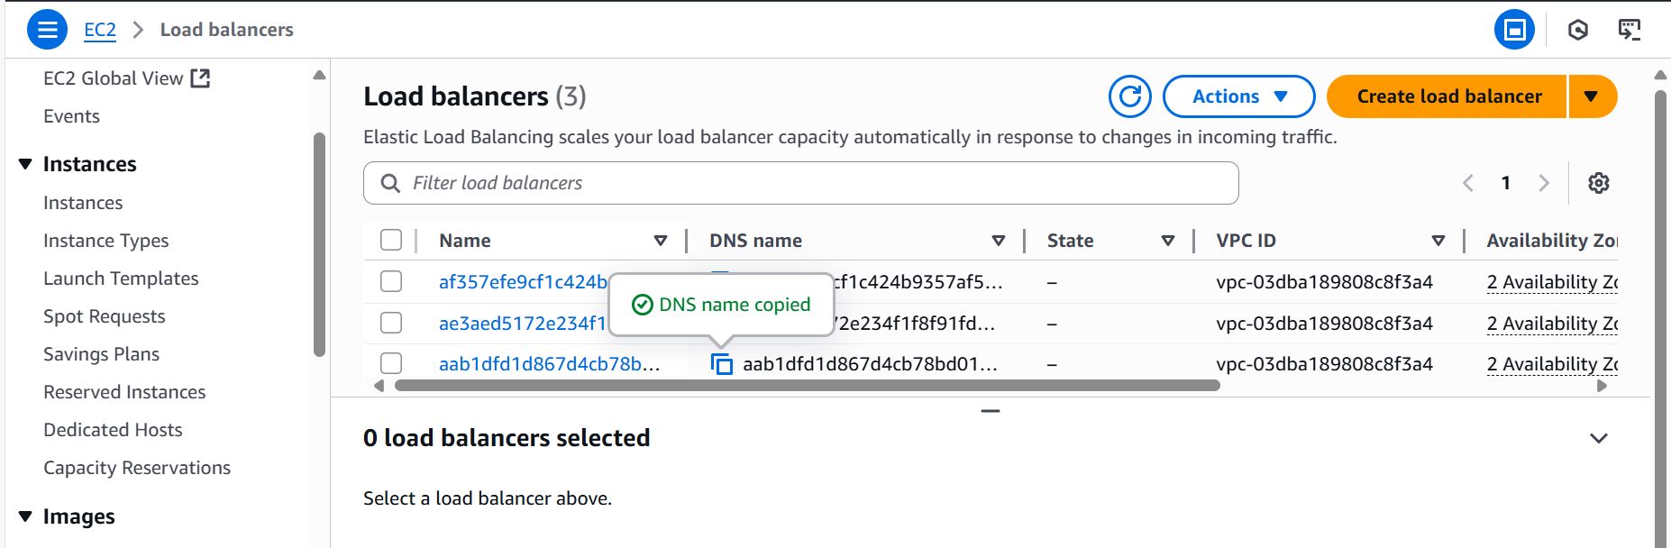

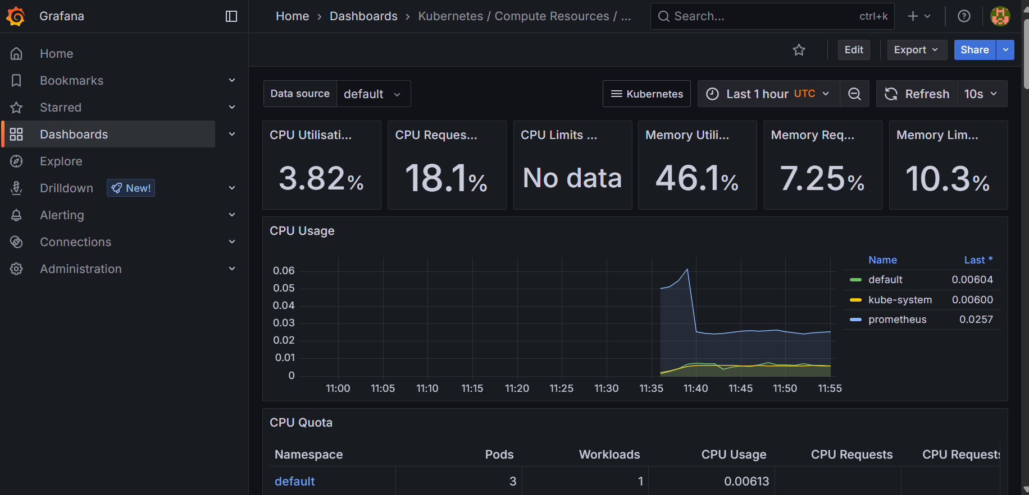

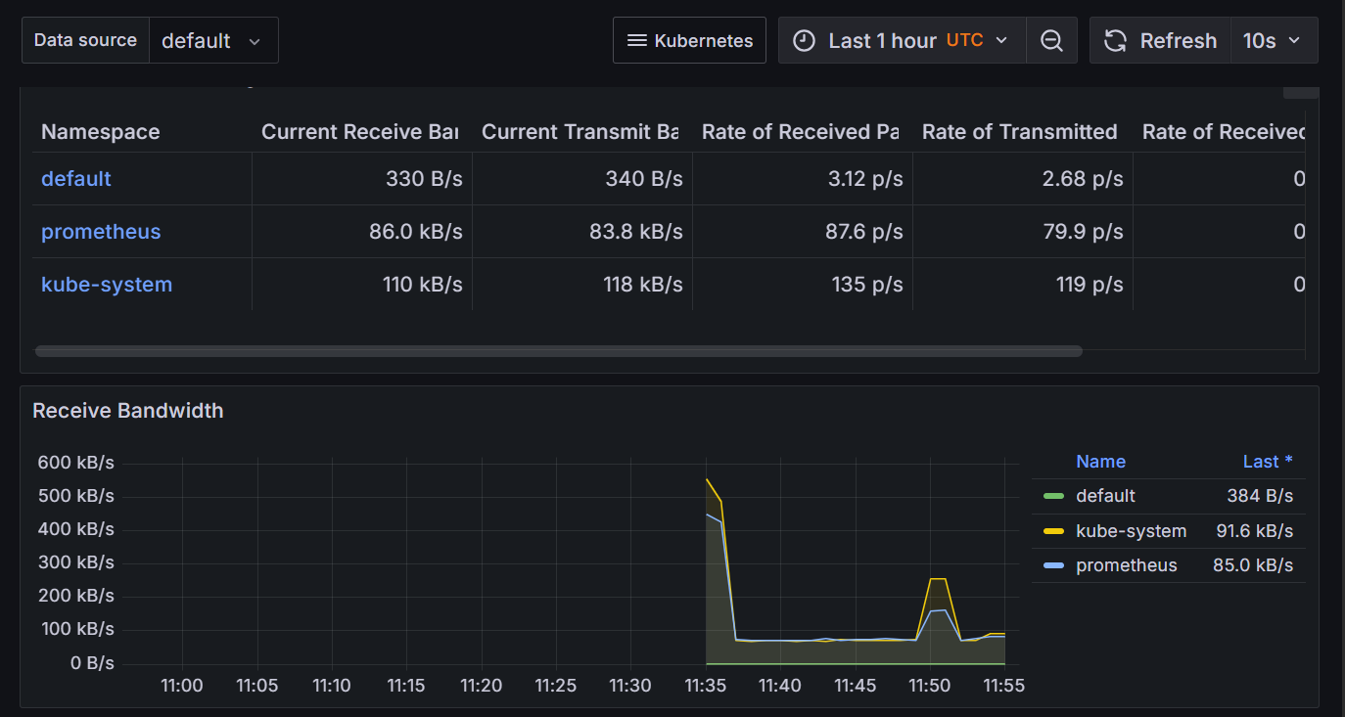

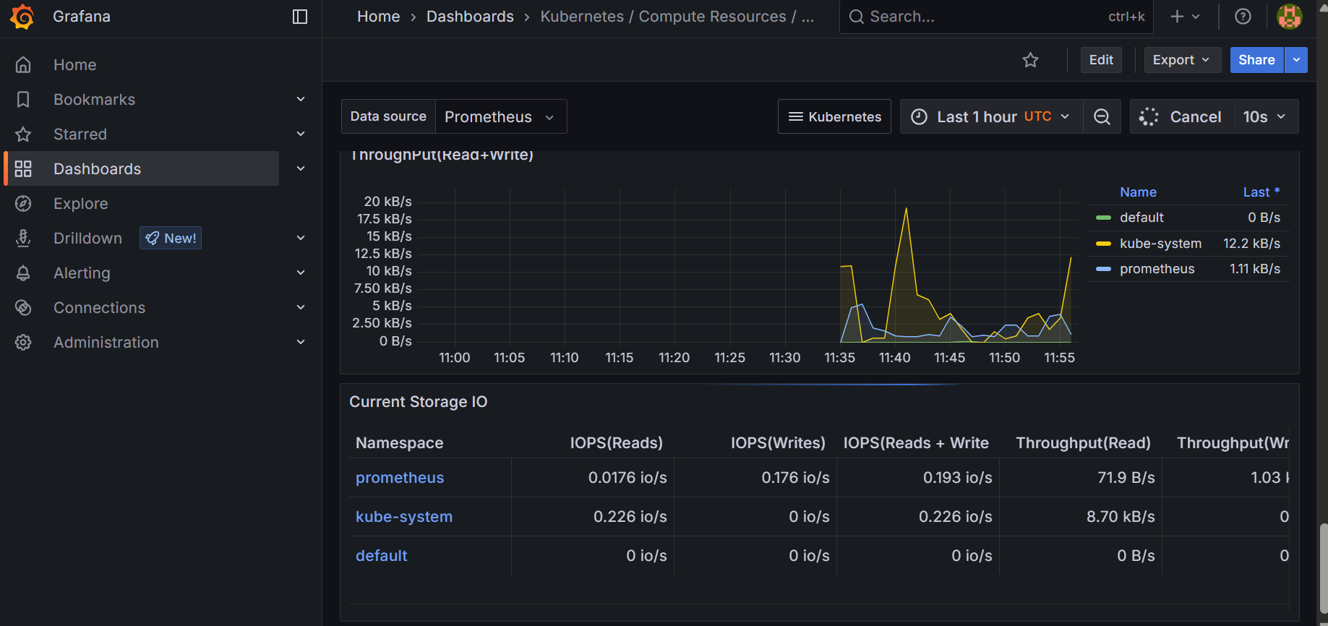

**14. Scaling and High Availability**

The system architecture is built to deliver both high scalability and continuous availability, using a combination of **Kubernetes** features and **AWS services**.

* **Cluster Autoscaler:**  
  Integrated with **Amazon EKS**, the Cluster Autoscaler automatically increases or decreases the number of EC2 worker nodes within the cluster. This mechanism ensures there are sufficient resources to accommodate new pods when demand spikes, supporting the scaling behavior of HPA.
* **Load Balancing Across Pods and Regions:**  
  Kubernetes Services of type **LoadBalancer** (commonly backed by **AWS ALB** or **NLB**) distribute incoming traffic across the running pods, ensuring high availability at the application level. Additionally, **Route 53** extends this load balancing capability by routing traffic across multiple regions, enhancing global resilience and performance.
* **Horizontal Pod Autoscaler (HPA):**  
  In the Kubernetes environment, the **HPA** dynamically adjusts the number of application pods based on real-time CPU usage or other performance metrics. This ensures the application can seamlessly manage fluctuations in user demand.
* **Multi-AZ MySQL Deployment with RDS:**  
  The **Amazon RDS** service is configured for **Multi-AZ deployments**, providing a standby replica of the MySQL database in a different Availability Zone. In the event of a primary database failure, RDS automatically fails over to the standby, improving database availability and fault tolerance.

**15. Key Project Outcomes**

The deployment of the **Budget banking application** has successfully delivered several significant technical and operational achievements:

* **Infrastructure as Code Implementation:**  
  The project leveraged both **AWS CloudFormation** and **Terraform** for provisioning infrastructure across different regions. This approach promotes consistency, version control, and automation in infrastructure management.
* **Multi-Tier, Multi-Region Deployment:**  
  The application was effectively deployed as a multi-tier architecture across two AWS regions — **us-east-1** and **us-west-1**, ensuring enhanced geographical redundancy and improved availability.
* **Secure Communication via EKS:**  
  The system ensures secure interactions between frontend and backend components through **Amazon EKS**, maintaining secure communication channels within the Kubernetes environment.
* **Fully Automated CI/CD Pipeline:**  
  End-to-end CI/CD processes were established to automate code integration, infrastructure deployment, and application rollout. This reduces manual intervention, speeds up deployments, and minimizes the risk of human error.
* **High Availability, Scalability, and Regional Resilience:**  
  The architecture is designed to be highly scalable, fault-tolerant, and resilient to region-level disruptions — a critical requirement for ensuring the reliability of banking systems.
* **Ongoing Code Quality and Security Checks:**  
  Integrated tools such as **SonarQube** and **Trivy** are continuously used to monitor code quality and detect vulnerabilities, ensuring secure and maintainable code.
* **Proactive Monitoring and Real-Time Alerts:**  
  Comprehensive observability is achieved using **Amazon CloudWatch**, **Grafana**, and **EventBridge**, providing real-time performance monitoring and automated alerts for prompt incident response.

**16. GitHub Repositories and Resources**

The source code, infrastructure configurations, and deployment templates for this project are maintained in the following **GitHub repositories** to ensure collaboration, version control, and automation:

* **Application Repository:**  
  Contains the complete application code, including backend logic, frontend components, Docker configurations, and Kubernetes manifests.  
  <https://github.com/Santhosh2010-ramesh/Budget-ledger.git>
* **CloudFormation Templates Repository:**  
  Stores all **AWS CloudFormation** templates required to provision core infrastructure resources for the project.  
  https://github.com/Santhosh2010-ramesh/Budget-ledger.git
* **Terraform Templates Repository:**  
  Includes **Terraform** configurations for deploying infrastructure components in a repeatable and version-controlled manner.  
  https://github.com/Santhosh2010-ramesh/Argocd.git

The application is accessible via the custom domain: <http://santhoshramesh.com>

**17. Local Development Environment Setup**

Developers contributing to this project should set up the following tools and configurations to enable efficient local development and testing:

* **Java Development Kit (JDK):**  
  Install **JDK 21**, as specified in the project's pom.xml and Dockerfile.
* **Maven:**  
  Required for building the project and managing dependencies.
* **Docker:**  
  Install **Docker Desktop** to build and run application containers locally.
* **Integrated Development Environment (IDE):**  
  Recommended IDEs include **IntelliJ IDEA** or **Visual Studio Code**, ideally with Spring Boot extensions for enhanced productivity.
* **Local MySQL Database & kubectl:**  
  For testing and development, set up a **MySQL instance**, either natively or via **Docker Compose**. Connection details for the database should be specified in application.properties or application.yml under the local profile.  
  Install **kubectl** to manage local Kubernetes clusters like **Minikube** or **Kind**, useful for testing container orchestration locally.